CHECK OUT REPORT OF CONDITION AT

46 WARWICK CHAMBERS

PATER STREET

LONDON

W8 6EW

4TH SEPTEMBER 2019 / 07TH SEPTEMBER 2020

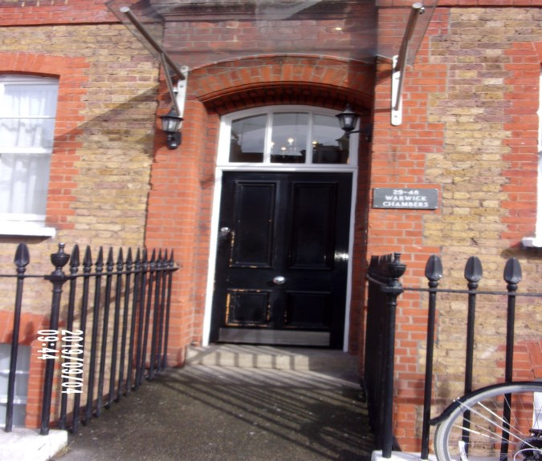

|  |  |
| --- | --- |
| **CLIENT:** | London Central Portfolio / London Central Portfolio |
| **INSTRUCTED BY:** | Annabel Hughes |
| **JOB NO:** | 3278 |
| **REF:** | MBPS-002 / MBPS-002 |
| **INSPECTED BY:** | Janice Richardson |
| **PROPERTY SIZE:** | 1 Reception / 2 Bedrooms / 2 Bathrooms - Furnished Flat |

'WINDY RIDGE' [99 COWLEY HILL, BOREHAMWOOD, HERTS, WD6 5NA](https://maps.google.com/?q=99+COWLEY+HILL,+BOREHAMWOOD,+HERTS,+WD6+5NA&entry=gmail&source=g),TEL: 020 8 386 0950 - MOBILE: 077 67 647 647  
EMAIL: [info@inventorys.net](mailto:info@inventorys.net)[www.inventorys.net](http://www.inventorys.net/)  
Registered No: 4263261 VAT No: 822 9322 12

Safety Disclaimer

This inventory report is prepared as an ‘as seen snapshot’ of the property and its contents at the time of the designated inspection and is compiled as a fair and accurate record for the properties internal condition and contents. This does not form any part of a valuation or structural report.

This inventory is compiled on the basis that all items listed are in good order and clean. Any defects or soiling are noted where appropriate. Where inspections are carried out and the tenants’ belongings are in situ, it can be difficult for clerks to differentiate to that belonging to the landlord or tenant. Should the report contain inaccuracies the clerk (Independent Inventories (UK) Ltd ) will not be held responsible.

The clerk preparing the inventory is not an expert in electrical appliances, antiques, furniture style, fabrics, flooring, etc. All descriptions within this report are for identification purposes only in order that each item can be compared to its condition at the commencement of the tenancy.

Lofts and Cellars are not included unless they are converted and safely accessible. Contents will therefore not be noted or checked at check in or checkout.

Plants and shrubs will not be itemised.

Belongings left by the landlord/agent in a locked room or outbuilding will not be inventoried and are the sole responsibility of the Landlord/agent. Items in garages/sheds such as garden equipment and tools will be inventoried, however tins of paint will not be itemised.

We do not undertake to move heavy items of furniture or access lofts, high-level cupboards, or any other inaccessible places. Contents which have been left in the above-mentioned areas, which have not been inventoried, are the sole responsibility on the landlord. We also do not undertake to open windows, but will confirm whether keys have been seen or not.

Any electrical appliances tested will be for power only and only where practicable. The clerks are not qualified electricians and will only confirm the visual condition of the electrical socket, wiring and or fitting as seen. Boilers, Heating Systems, Gas Fires, Water Supply and Radiators are not tested, and Independent Inventories (UK) Ltd will not take any responsibility for units left either on or off even if on automatic timers. Where smoke alarms and CO Detectors are tested this is for power only and should not be taken to mean that the alarms are in full working order. We only state their presence and cannot state the functioning of this equipment. No responsibility is taken for any damage or malfunction occurring during the testing of such alarms.

The relevant utility companies must check all meter readings, as we cannot be held responsible for any discrepancies. We are not held liable should meters not be located or inaccessible to read. For Health and Safety reasons we do not expect our clerks to access high level areas which involve using ladders/chairs.

The Fire & safety Regulations regarding furnishings, gas, electrical & similar services are ultimately the responsibility of the instructing principle. Where the inventory notes FFR label seen, this should not be interpreted to mean that the item complies with the furniture & furnishings (fire) (safety) (Amendments) 1993. It is a record that the item had a label as described or similar to that detailed in the Guide to the regulations as published by the Department of Trade & Industry, January 1997, (or subsequent edition), attached at the time the inventory was complied.

Blinds in the premises are visually checked. We are unable to verify that the blinds comply with child safety requirements of BS EN 131202009 + A1:2014 placed on the manufacturer, supplier and professional installation of internal window blinds

It is the responsibility of the landlord/managing agent/tenant to agree between themselves the accuracy of the report, and Independent Inventories (UK) Ltd should be notified within 7 days of receipt of the report of any discrepancies within the report.

GENERAL GUIDANCE NOTES

Independent Inventories do not have site of tenancy agreements or other agreements made between the tenant, landlord and management company. As these are guidance notes only it is always advisable that the tenancy agreement is cross referenced. This report will indicate whether in our opinion the tenant is liable for the deterioration or whether it is considered fair wear & tear. Independent Inventories may suggest maintenance, cleaning or tenant’s liability at checkout, but the final responsibility of these suggestions will fall with the landlord or managing agent in respect of the original tenancy agreement. We do not suggest costs of any items, these should be sourced from the relevant contractors by the landlord or managing agent.

CLEANING

We recommend that a professional cleaning company is employed at the end of the tenancy, unless alternative arrangements have been agreed with the Landlord/Managing Agent. Receipts from professional cleaning and carpet cleaning companies must be present to the clerk at the checkout inspection.

If the standard of cleaning is not satisfactory most Landlords/Managing Agents will contract a cleaner and their charges will be charged to the tenant unless otherwise stated in the tenancy agreement.

DECORATION

It is accepted that during the course of the day to day living scuffs will appear on walls and woodwork. However should the marks be found to be excessive charges will be made to you the tenant, unless otherwise stated in the tenancy agreement.

LIGHTING

If the lights are working at checkin then it is normal, if lights are not working at checkout, for these to be the responsibility of the tenant to replace bulbs or to be charged accordingly, unless otherwise stated in the tenancy agreement.

GARDENS/PATIO

If the standard of the garden/patio is found to be untidy compared to the start of the tenancy the Landlord/Managing Agent are entitled to employ a contract gardener and the charge will be made to you the tenant, unless otherwise stated in the tenancy agreement.

MAINTENANCE ISSUES

We recommended should any maintenance issues arise you contact the Landlord/Managing Agent immediately so they can deal with the matter. Should we recommend items require maintenance once a property has been checked out, this is purely stating that an item will require fixing/attention, we are not advising as to whose responsibility this and your tenancy agreement will need to be checked.

CHANGES TO PROPERTY

We recommend that if you wish to make any changes to the décor or remove any of the Landlords belongings you contact the Landlord/Managing Agent for permission and have this confirmed in writing to ensure there are no discrepancies at the end of the tenancy.

TENANTS INFORMATION FOR CHECKING OUT OF PROPERTY

It is important at the checkout that:

1. All cleaning should be completed prior to the checkout appointment as per the tenancy agreement.
2. All personal items must be removed prior to the check out.
3. All items should be in the same location as per the inventory, any stored items should be unpacked and also returned to the same location.
4. If the Inventory clerk has to search for items or you still have belongings in the property to be removed this will result in additional charges being made to the tenant.
5. All beds should be left unmade with the linen folded. Bedding & towels should be cleaned & ironed where relevant.
6. All food items should be removed, freezers defrosted & doors left open & electricity turned off.
7. All light bulbs etc. should all be in working order as at check in.

The property should be left in a clean and tidy condition especially carpets, curtains, windows, upholstery appliances etc. We would suggest that you refer to your tenancy agreement in this matter.

If you are not ready to leave it may not be possible to carry out the checkout. In this case a return visit will be necessary resulting in a cancellation charge.

All keys to the property must be handed over at the time of checking out to the Inventory clerk or alternatively to the agents prior to the check out taking place.

The Inventory Clerk acts as an independent and reasonable body and will avoid unnecessary criticism or derogatory comments when compiling or checking the Inventory.

At the termination of the tenancy the inventory will be checked and any obvious or significant discrepancies will be reported to the Managing Agent/Instructing Principal. This report will indicate whether in our opinion the tenant is liable for the deterioration or whether it is considered fair wear & tear. Normal fair wear and tear will be assessed on the lengthy of the tenancy and type occupancy.

INDEX

PAGE

|  |  |
| --- | --- |
| UTILITY READING | 1-3 |
|  |  |
| KEYS | 4 |
|  |  |
| GENERAL SUMMARY AT CHECK IN | 5 |
|  |  |
| INSTRUCTION MANUALS | 6 |
|  |  |
| ENTRANCE HALLWAY | 7-10 |
|  |  |
| BATHROOM | 11-17 |
|  |  |
| KITCHEN | 18-29 |
|  |  |
| BEDROOM 1 | 30-37 |
|  |  |
| ENSUITE | 38-44 |
|  |  |
| RECEPTION | 45-51 |
|  |  |
| BEDROOM 2 | 52-57 |
|  |  |
| DECLARATION AT CHECK IN | 58 |
|  |  |
| ADDITIONAL AMENDMENTS | 59 |
|  |  |
| CHECK IN SIGNED SCHEDULE OF CONDITION | 60-68 |

**UTILITY READINGS / KEY LIST& INSTRUCTION MANUALS**

|  |  |  |
| --- | --- | --- |
| **ELECTRIC** | **GAS** | **WATER** |
| METER NUMBER:  18L2111665 | METER NUMBER:  E06112261 | METER NUMBER:  N/A |
| READING:  Credit mode balance:1743  Rate 01 input: 625kwh | READING:  00237.333 | READING:  N/A |
| LOCATION:  Front exterior above door cupboard high level | LOCATION:  Bathroom cupboard | LOCATION:  N/A |

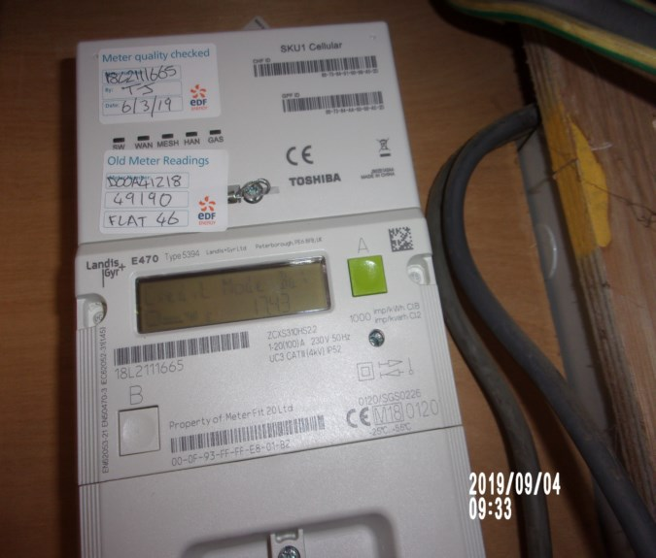 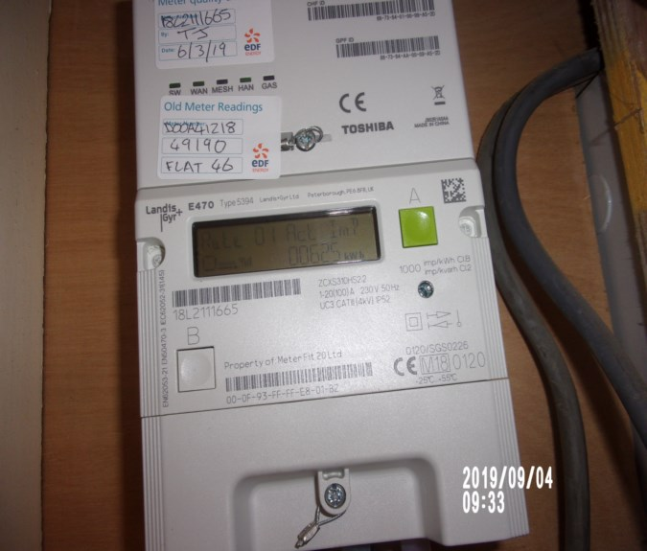

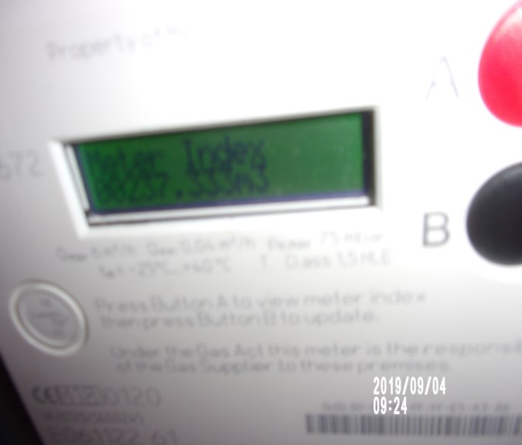

|  |  |  |
| --- | --- | --- |
| **ELECTRIC** | **GAS** | **WATER** |
| METER NUMBER:  18L2111665 | METER NUMBER:  E06112261 | METER NUMBER:  N/A |
| READING:  Credit mode balance:2363 | READING:  01212.600 | READING:  N/A |
| LOCATION:  Front exterior above door cupboard high level | LOCATION:  Bathroom cupboard | LOCATION:  N/A |

|  |
| --- |
| **LOCATION OF:** |

|  |  |  |
| --- | --- | --- |
| **STOP COCK** | Kitchen cupboard | |
| **FUSE BOARD** | Hallway | |
| **ALARM PANEL**  **This has not been tested** | N/a | MAKE: |

|  |
| --- |
| **FIRE SAFETY** |

|  |  |
| --- | --- |
| **SMOKE ALARM 1** | Power light on  Tested with canned smoke and working order  Location: Hallway |
| **SMOKE ALARM 2** | Power light on  Tested with canned smoke and working order  Location: Kitchen |
| **CARBON MONOXIDE ALARM** | Tested and working order |

|  |  |  |
| --- | --- | --- |
| **KEYS AT CHECKIN** | **KEYS AT CHECKOUT** | |
| **KEY TYPE / SERIAL NUMBER / QTY** | **KEY TYPE / SERIAL NUMBER / QTY** |
|  | 1 x Bramah 85d 11110 |
|  | 1 x yale |
|  |  |
|  |  |
|  |  |
|  |  |
| **KEYS RECEIVED BY: Management keys used**  F:\Preetha\II\10-Sep-2019\10-Sep-2019\46 WARWICK CHAMBERS - IN\68 photos 46 warwick\New folder\65 keys (Copy).JPG | **KEYS RETURNED TO: Agent** | |

|  |
| --- |
| **GENERAL SUMMARY** |

|  |  |  |
| --- | --- | --- |
| **ITEM** | **CHECKIN NOTES** | **CHECKOUT NOTES** |

|  |  |  |  |
| --- | --- | --- | --- |
| **GENERAL CONDITION** | | Domestically cleaned for the start of tenancy | Appears to be with odd omissions.  No receipt seen to conform |
| **ODOUR** | | From bathroom cupboard | N/A |
| **DECORATIVE ORDER / WOODWORK** | | Defects as noted  Dusty  Woodwork scuffed/chipped | Defects as noted  Woodwork scuffed/chipped |
| **FLOORING** | | Defects as noted  Requires further cleaning | Defects as noted  Vacuumed for end of tenancy |
| **CURTAINS / BLINDS** | | Requires further cleaning  Defects as noted | Defects as noted |
| **BLIND REGULATIONS** | | Regulations not met in some areas |  |
| **UPHOLSTERY** | | Defects as noted | Defects as noted |
| **FFR LABELS** | Not seen only viewed where visible  Mattress bedroom 1 FFR label seen  Mattress bedroom 2 FFR label seen | |  |
| **LINEN** | In use | | Freshly laundered |
| **LIGHTS** | Bulbs not working | | Bulbs missing / not working |
| **KITCHEN / APPLIANCES** | All appliances power tested  Fridge/ freezer left shut power on  Final wipe required | | All appliances power tested  Fridge/ freezer left shut power off |
| **BATHROOMS/**  **WC** | Water outlets tested and working | | Water outlets tested and working where accessible |
| **WINDOWS** | Fitments complete / Clean to interior | | Fitments complete / Clean to interior |

|  |  |  |
| --- | --- | --- |
| **GARDEN /**  **TERRACE** | N/A | N/A |

|  |  |
| --- | --- |
| **MANUALS SUPPLIED AT**  **CHECKIN** | **MANUALS RETURNED AT**  **CHECKOUT** |
| **APPLIANCE / MAKE** | **APPLIANCE/MAKE** |
| None provided | NONE |
|  |  |
|  |  |

 *N.B – Heavy items will not be moved or inspected behind/under, for health& safety reasons. We will not be held liable should any damages/stains/marks be found during the tenancy in these areas. Should the occupant find any of the above they should, inform the landlord/agent immediately and if/where possible take photographic evidence and pass to the relevant parties.

 This camera symbol throughout the Inventory check in/out indicates where a photo has been taken. Photos can be found at the back of each room in the report with the relevant headings

# ENTRANCE HALL

|  |  |  |  |  |
| --- | --- | --- | --- | --- |
| Entrance Door | White painted frame  Dark blue painted panelled door  Chrome No 46  Chrome knocker  Chrome letter flap  Chrome spy hole  Brass and chrome Yale upper lock  Chrome Yale mortise lock to low level  Silver coloured metal threshold runner  Coir mat to exterior | 1. Old defects under  2. Chip mid level right hand side  3. Several odd chips mid to low level left hand side  4. Chips to the edge of the door mid to low level  5. Paint marks to the edge of the door  6. Scuffing to the base of the door  Patchy paintwork to exterior door throughout  Scuffing and rub marks at mid to low level  All attachments intact |  |  |
| Interior | White painted frame  White painted panel over the door with wall mounted Wylex fuse box  White painted panelled door  Era latch lock upper lever  Chrome Chubb style Union lock  Chrome letter flap and cover  2 x White painted over bolt to reverse of the knocker  Chrome Chubb spy hole with cover  Chrome over door hook fitment | Removable coat hook over door  Scattered scuff  Painted over chips  Slight hairline cracking to the panels at high level |  |  |

# ENTRANCE HALL

|  |  |  |  |
| --- | --- | --- | --- |
| **Walls** | Painted pale grey | 1. Painted over defects  1 x brass hook seen to the right-hand side at high level |  |
|  | Back wall:  Fuse box to high level |  |  |
|  | Left hand side wall:  Entrance to Bathroom  1 x Chrome single light switch  1 x White Worchester thermostat control  1 x Chrome double light switch  2 x White isolator switches  1 x Power breaker point | General usage scuff mid level  Stress crack upper level  Painted over defects left hand side of Worchester, gap under possibly from size opening to low level |  |
|  | Facing wall:  Entrance to Bedroom 1 |  |  |
|  | Right hand side wall  1 x Chrome light switch  1 x White Bitron video entry phone  Entrance to Bedroom 2 and Reception room | 1. Entry phone not tested  Heavy scuff above radiator |  |

# ENTRANCE HALL

|  |  |  |  |  |
| --- | --- | --- | --- | --- |
| **Ceiling** | Painted white  Fire alarm fitted  1 x Ceiling mounted smoke alarm / sprinkler system | 1. Green light seen  2. Not tested  1. Light seen  2. Aged and in use  Appears to be intact  Odd scuff  Smoke alarm tested and working for power |  | Lighting |
| **Lighting** | 3 x Recessed halogen spot lights with chrome collar rims | 1 x not working |  |  |
| **Woodwork** | Painted white | 1. Few light scuffs  1 or 2 x chips seen at an angle to skirting  1 x more prominent left hand side of kitchen  ~~Dusty~~ |  |  |
| **Flooring** | Fully fitted light wood parquet flooring | 1. Couple of very light scratches to the walkway  2. Very light usage ~~and dust~~ |  |  |
| **Radiator** | Enclosed behind a box casing with white painted ledge over, white painted casing with chrome mesh panel to the front | 1. Not closely inspected to the radiator  Usage to top shelf  Light scorch mark to the front surface |  |  |

Flat door Hallway

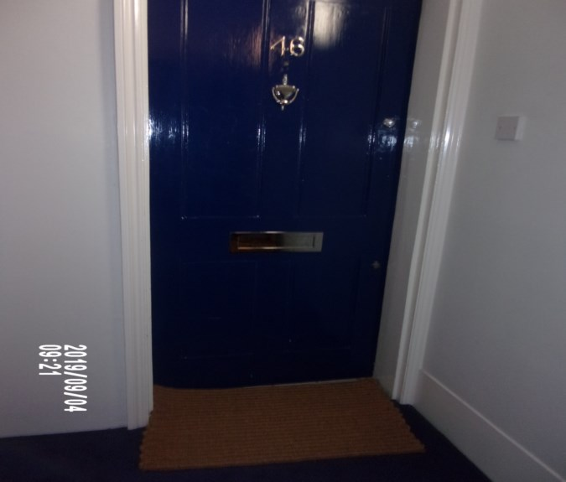 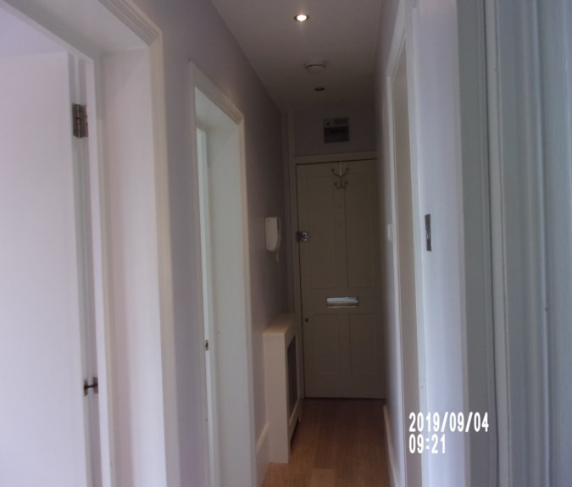

Heat alarm Smoke alarm

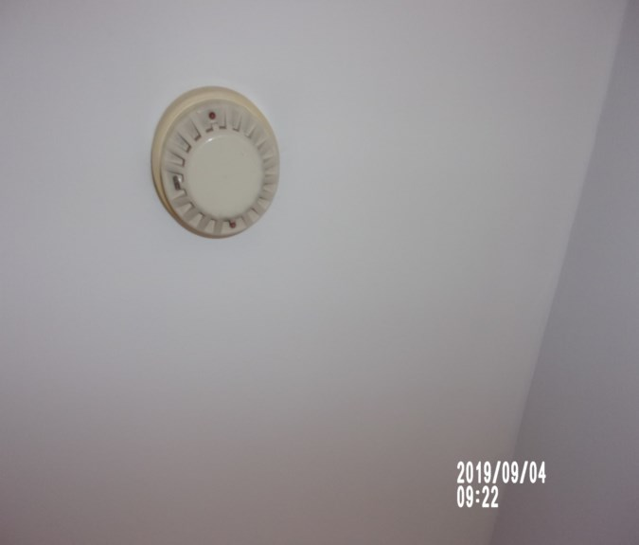 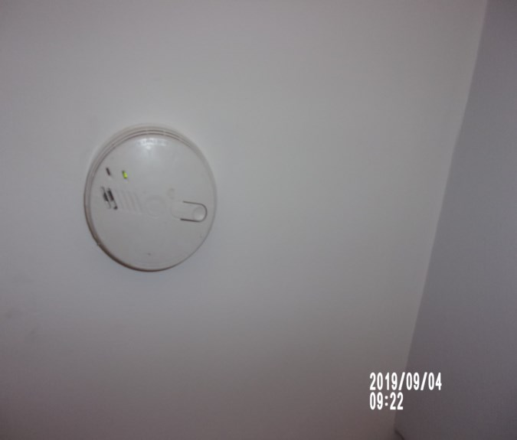

# BATHROOM

|  |  |  |  |  |
| --- | --- | --- | --- | --- |
| **Door** | White painted frame, white painted flush door  Chrome lever handle  Silver coloured metal threshold runner | 1. Runner is in use  2. Fire chain removed  3. Handle angled  Exterior frame intact, odd scuff  Exterior door scattered scuff heavier above handle |  |  |
| **Interior** | White painted frame, white painted flush door  Chrome lever handle  Chrome over door hook fitment | 1. Handle angled  Appear to be intact  Odd scuff to door  Crack to left hand side base |  |  |
| **Ceiling** | Painted white | Appears to be in good order  Gapping between recessed spotlight and ceiling above bathtub |  | Lighting |
| **Lighting** | 3 x Recessed halogen spot lights with chrome collar rims | 1. Fitting over bath is angled  ~~1 x not~~ All working |  |  |

**BATHROOM**

|  |  |  |  |
| --- | --- | --- | --- |
| **Walls** | Part painted cream  Part beige marble effect mattering with dark cement grouting | Appear to be intact  All tiles showing some white scuffing to the front surface  Discolouration to the grout in places  No crack tile seen |  |
|  | Back wall: |  |  |
|  | Left hand side wall:  1 x Chrome and black shavers only socket  1 x Chrome hook | 1. Old defects under  Odd scuff |  |
|  | Facing wall: | 1. Grout to tiled discoloured  Onset of mould |  |
| **Flooring** | Black matt slate effect tiling | 1. As fitted  2. Grout discoloured  3. 1 x small edge chip to 1 tile forward of the sink  4. Minor blemish marks  6. Some pale marks  Needs further clean |  |
|  |  |  |  |

**BATHROOM**

|  |  |  |  |
| --- | --- | --- | --- |
| **Radiator** | 1 x chrome towel rail radiator | 1. Not tested  2. Chrome peeling to left hand side  Water residue  3 of fittings chipped |  |
| **Basin** | White ceramic basin  Chrome push plug  Chrome mixer tap  Perspex splash back behind | Water tested and working  Slight tarnishing around waste  Some light signs of scratching and tarnishing to mixer tap  Scale to tap ~~and plug~~  ~~Splash back requires further clean~~ |  |
| **WC** | White ceramic low level flush WC  White plastic seat and lid  Chrome push flush | 1. Flush tested and working  Light stain to interior |  |

# BATHROOM

|  |  |  |  |
| --- | --- | --- | --- |
| **Bath** | White enamel steel bath  Chrome waste  Chrome pop up plug control  Chrome framed shower guard with rubber seal  Wall mounted chrome shower controls with wall mounted bath controls  Wall mounted chrome shower holder with head and flex  Wall mounted chrome drench shower with control  Beige tiled bath panel  Beige tiled ledge to the end | 1. Grout discoloured to the bath panel  Shower hose some rusting seen  All showerheads scaled  Some heavy discolouration to the shower guard seal  Not tested |  |
| **Contents** | 1 x Rectangular mirror panel above the basin | 1. Silvering to low level and upper level |  |
|  | 1 x Chrome toilet roll holder | Intact |  |
|  | 1 x White fitted shelving unit with white surround  4 x Adjustable glass shelves  1 x White base shelf  1 x Mirrored panel to the back | ~~Needs further clean~~  Wear to base |  |

# BATHROOM

|  |  |  |  |
| --- | --- | --- | --- |
| **Fitted cupboard** | White painted flush doors with magnetic catches   Chrome pull handles  Interior:  Cream painted walls  Cream painted floors | 1. Usage marks to the walls and scuffs  2. Floor is heavily scuffed and ring marked  Intact  ~~Mouldy odour from interior~~ |  |
| **Fitted cupboard contents** | Housing:  Gas meter  1 x Chrome hanging rail  2 x Tins of paint – 3 x more tins  1 x Wall mounted white plastic light switch with ceiling mounted halogen light  1 x bucket seen  Mop  Dustpan and brush | 1. Tarnished and marked  Not working  Mop in use  Dustpan and brush in use |  |
| **Additional** | Vacuum, box with items |  |  |

Bathroom Bathroom

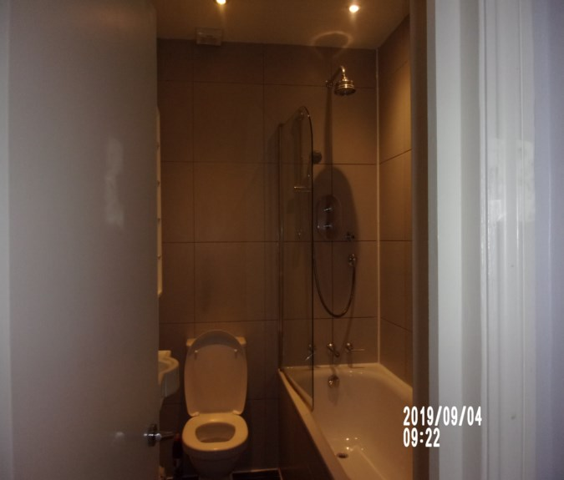 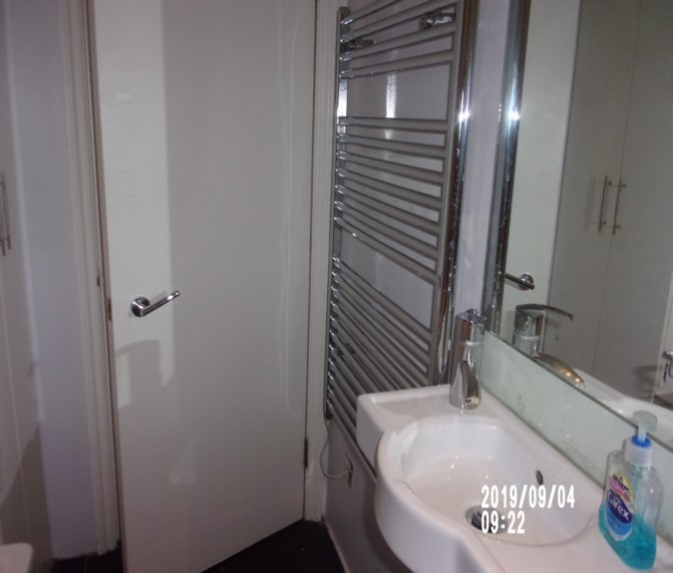

Hand basin Chip fittings radiator

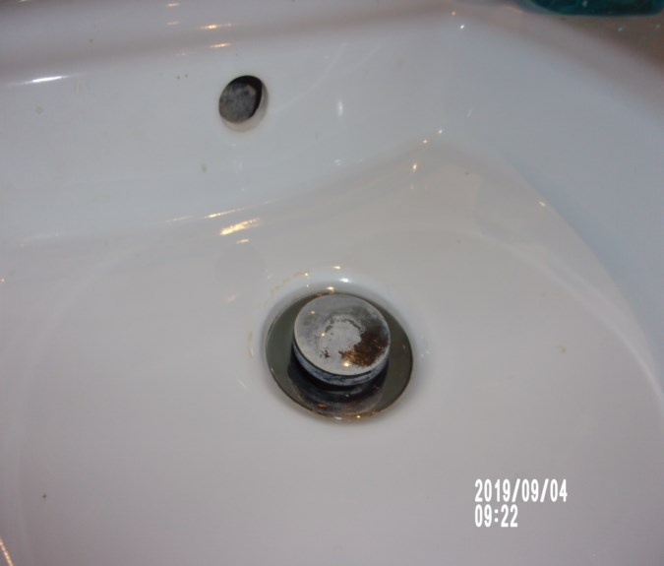 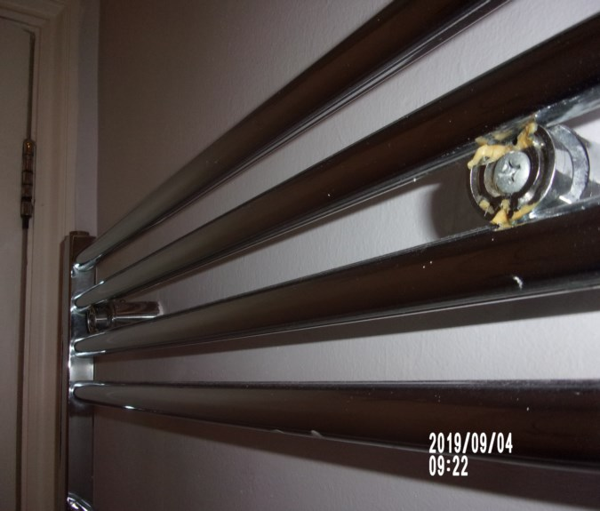

Shower door strip stain Showerhead not clean

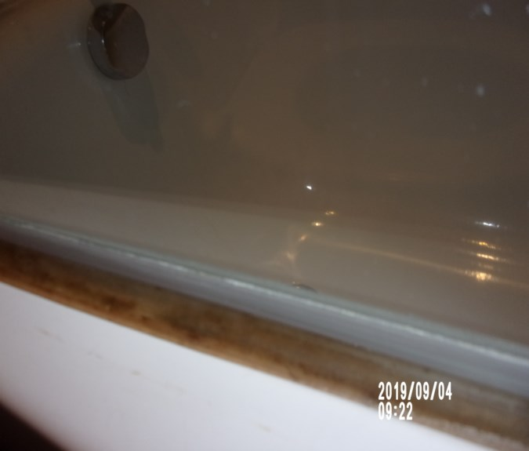 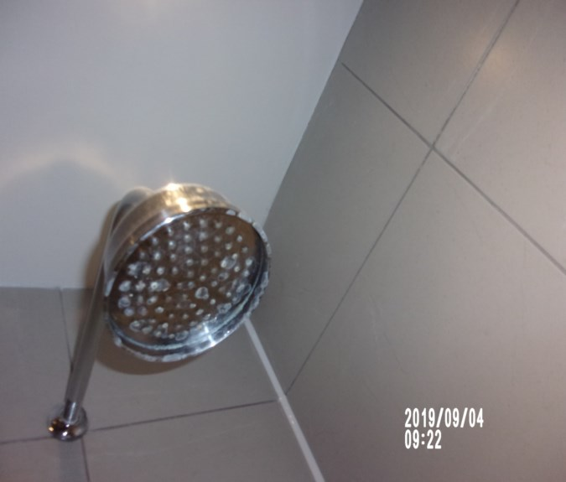

Bathroom Bathroom

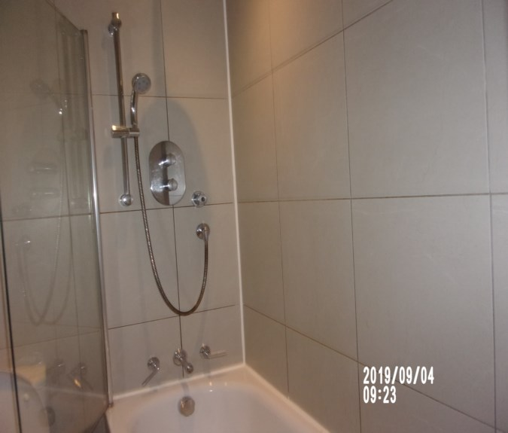 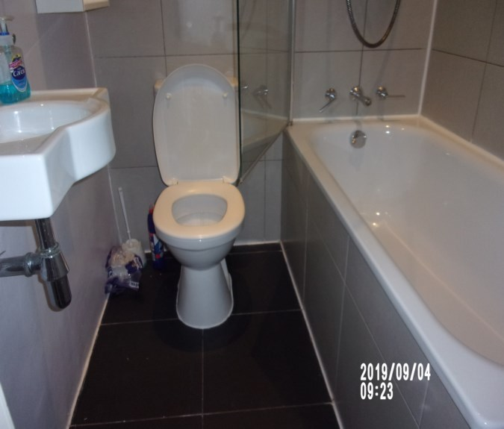

Bathroom cupboard Bathroom cupboard

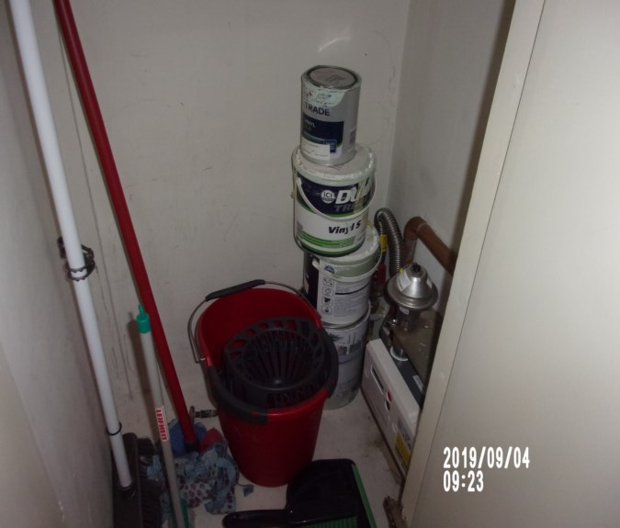 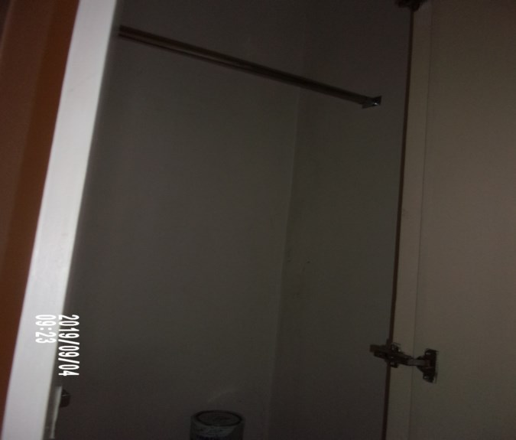

**KITCHEN**

|  |  |  |  |  |
| --- | --- | --- | --- | --- |
| **Door** | White painted frame, white painted flush door  Chrome lever handle | 1. Fire chain removed  2. Fitting loose  Exterior door 1 x scuff at high and 1 scuff at low level  Some light chipping seen to the bottom edge at an angle and top edge at an angle  Additional scuff to door |  |  |
| **Interior** | White painted frame, white painted flush door  Chrome lever handle | 1. 2 x screws missing from the handle  2. Few edge nicks to door  3. 2 x Scrapes from fridge freezer handles  4. Chips low level  Interior frame appears to be intact  Surround for lever handle currently missing |  |  |

**KITCHEN**

|  |  |  |  |  |
| --- | --- | --- | --- | --- |
| **Ceiling** | Painted white  1 x Ceiling mounted Emcovent extractor fan  Smoke detector | 1. Not tested  Appears to be in good order  Smoke detector green light seen  Tested and working |  | Lighting |
| **Lighting** | 3 x Recessed halogen spot lights with chrome collar rims | ~~All~~ 2 x lights tested and working |  |  |
| **Walls** | Part pale light grey  Part painted light green  Part brushed stainless steel splashback and Perspex stand up | 1. All painted sections appear to be intact 2. Old defects underneath |  |
|  | Back wall: | 1. Old defects under |  |
|  | Left hand side wall: | 1. Old defects under |  |
|  | Facing wall:  1 x Chrome double socket  5 x Chrome single fuse points  Black rack and 2+5 x hooks | 1. 2 x over painted screws  2. 2 x Hooks added |  |
|  | Right hand side wall |  |  |
| **Woodwork** | Painted white | Appears to be intact  ~~Dusty~~ |  |

**KITCHEN**

|  |  |  |  |
| --- | --- | --- | --- |
| **Flooring** | Light wood laminate flooring  1 x Floor mounted chrome and black rubber tipped door stop | 1. Heavy scratching to the centre  2. 2 x Heavier scratches forward of the dishwasher  Further use |  |
| **Units** | White laminate doors and black gloss laminate doors  Brushed steel pulls |  |  |
| **Wall unit 1** | Fascia to the Fridge/Freezer  White painted door  1 x Shelf  1 x Single socket to the back wall  CDA fridge:  2 x Full length door compartments – 1 with lid  1 x ½ length door compartment  2 x Full length glass shelves  1 x ½ length plastic salad box  2 x Full plastic salad box  1 x ½ plastic white shelf  1 x Cooler box  1 x Light | 1. Door is different from the rest of the units  2. Scuff marks to the back wall  Tested only for power  Light not tested ~~not working~~  Clean to interior  Lid crack to 1 x side  Crack to front interior  ~~Freezer iced~~ |  |

**KITCHEN**

|  |  |  |  |
| --- | --- | --- | --- |
| **Wall unit 2** | Double unit with textured glazed panel to the front  Interior:  2 x Shelves  1 x Base shelf | Appears to be intact and in good order |  |
| **Wall unit 3** | Single unit with black gloss door  Interior:  2 x Shelves  1 x Base shelf |  |  |
| **Base unit 1** | White fascia door to the Indesit washer dryer with magnetic catch  Serial number 303158266 | Large crack to door fascia low level  Exterior door top right hand side chipping seen to the laminate prominent approximately 2 inch chips  ~~Soap tray needs final clean~~  Sealant to interior ingrained staining seen  Tested for power  ~~Hinge loose- requires tightening or further maintenance required slightly loose~~ |  |

**KITCHEN**

|  |  |  |  |
| --- | --- | --- | --- |
| **Base unit 2** | Single unit under sink with black gloss door  Interior:  1 x Base shelf | Appears to be intact  Clean to interior |  |
| **Base unit 3** | Slim unit with white door front  Interior:  2 x Chrome herb racks | In good order |  |
| **Base unit 4** | Fascia door black gloss to the Indesit dishwasher DIS 04  2 x Grey plastic crockery racks  1 x Blue plastic cutlery rack | Tested for power  Unable to read serial number  ~~Not~~ clean to interior |  |
| **Base unit 5** | 3 x Drawer unit with white fronts  Grey interiors | Intact and in good order |  |
| **Base unit 6** | Open unit  1 x Base shelf  Fascia below oven spiting | Intact and in good order |  |

**KITCHEN**

|  |  |  |  |
| --- | --- | --- | --- |
| **Worktop** | Dark wood grain effect laminate worktop | 1. Several knife cuts and scratches particularly forward of the sink and left-hand side of the hob and above the dishwasher  2. Generally in use  3. Join is lifting and showing  4. White scale marks behind and to the left-hand side of the sink  5. Further usage |  |
| **Kickboard** | White kickboard | Intact and clean to the top surface |  |
| **Hob** | Black Ceran 4-ring hob | 1. Controls and fittings complete  2. Heavy scratches to the rings particularly to the front left-hand side ring – long heavy deep scratches  3. Power tested  Well in use  Tested for power |  |

**KITCHEN**

|  |  |  |  |
| --- | --- | --- | --- |
| **Extractor** | Stainless steel cooker hood  2 x Light fittings and covers | 1. Controls and fittings complete  3. Tested and working  Light working order |  |
| **Oven** | Stainless steel and glass fronted Baumatic oven  Interior:  1 x Rack shelf  1 x Grill pan and rack  Serial No: 072702110 | 1. Power tested  1 x knob control to exterior has crack  Interior strip is loose  Pan needs further clean  Drip marks to door |  |
| **Sink** | Stainless steel single sink with drainer  Chrome mixer tap  1 x black plastic plug and chain | 1. Scratches to the bowl and drainer  Water working order  ~~Not~~ clean  Scale to tap |  |
| **Manuals** | ~~Thermostat~~  ~~Filter and boiler~~ |  |  |
| **Contents** | 1 x Rectangular black and grey granite chopping board |  |  |
|  | 1 x Floor mounted black and chrome rubber door stop | Intact |  |

**KITCHEN**

|  |  |  |  |
| --- | --- | --- | --- |
| **Miscellaneous items** | Assortment of mismatched utensils  Assortment of mismatched cutlery  1 x dust pan and brush seen | All appear to be in used order  In used order  Brush seen and noted in bathroom cupboard |  |
|  | 4x white mugs  1 x white bowl – 3 x more  3 x wine glasses – 1 x more  Knife block with 5 x assorted knives  Additional see photo  6 x dessert spoons  6 x teaspoons  5 x knives  5 x forks  3 x black handled knives  1 x bottle/ can opener  ~~Crockery on dining table~~  4 x white dinner plates  4 x white side plates  4 x soup bowls  4 x wine glasses  3 x cork coasters |  |  |

Kitchen Kitchen

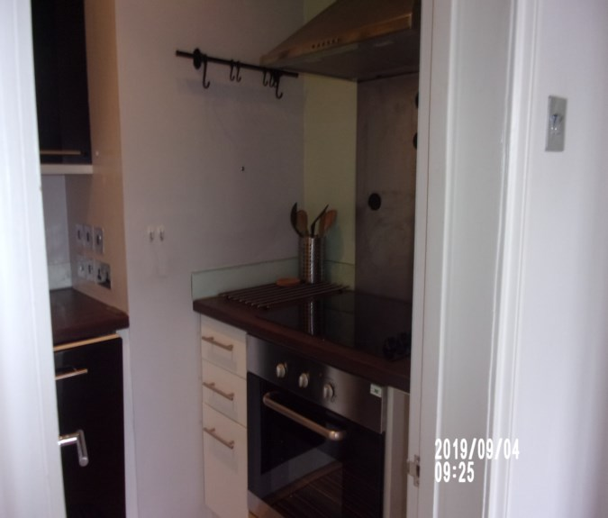 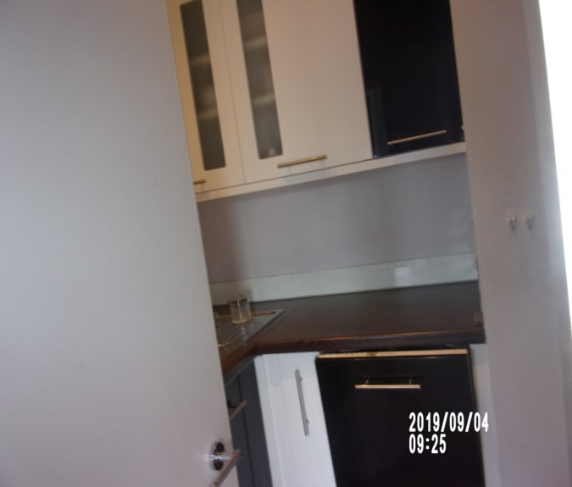

Sink Fridge

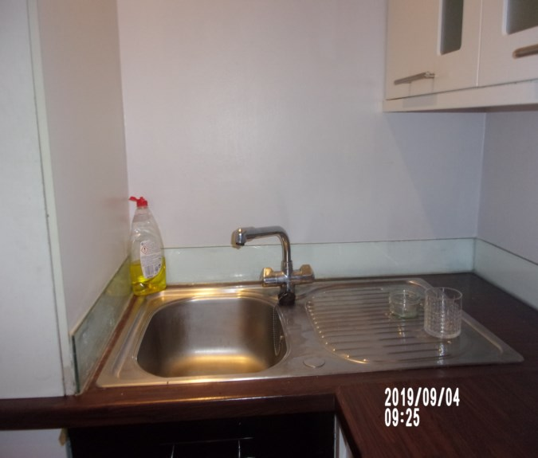 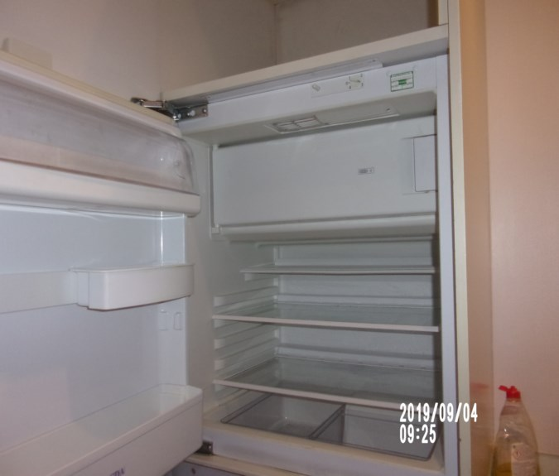

Crack front interior fridge Washing machine

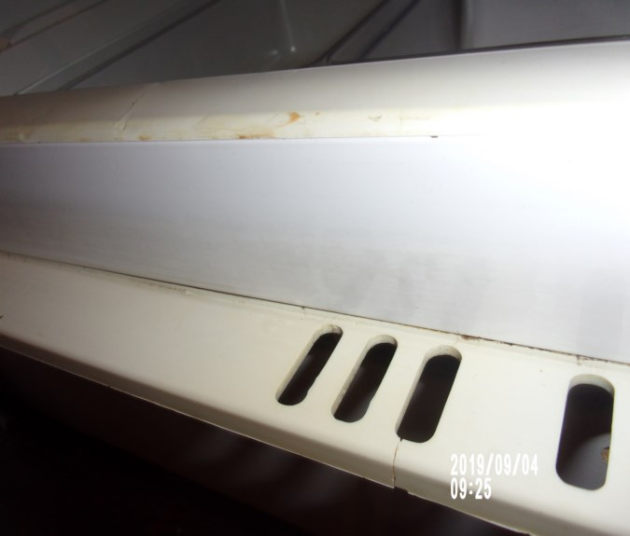 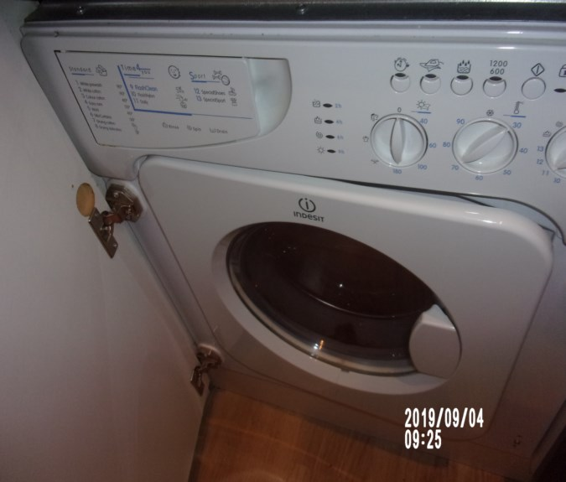

Drawer washing machine Seal washing machine

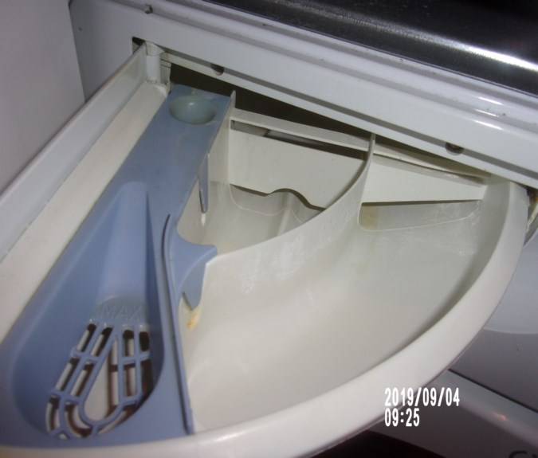 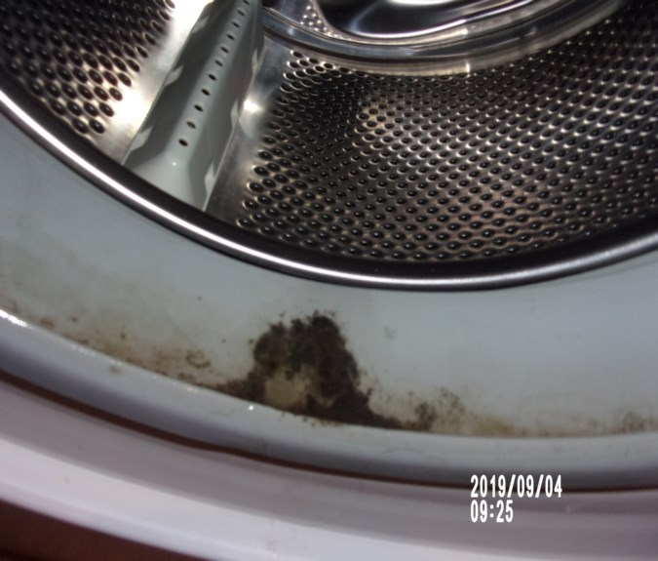

Under sink unit Dishwasher

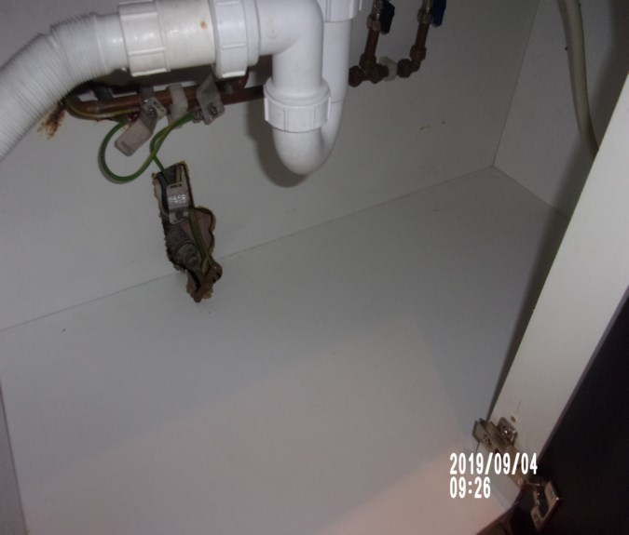 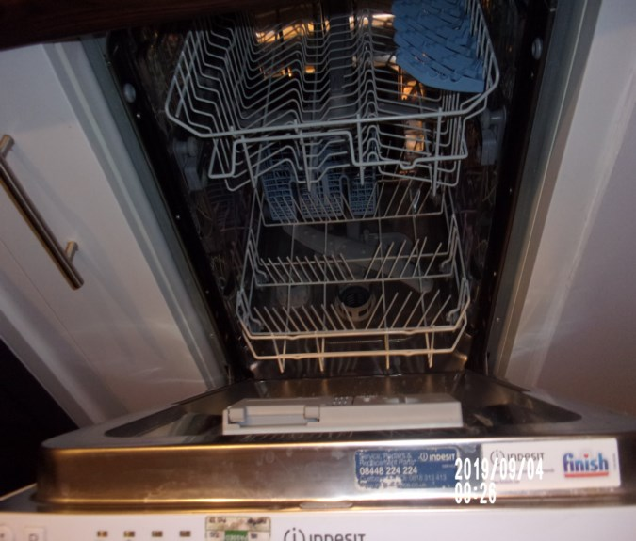

Extractor hood Items in drawer

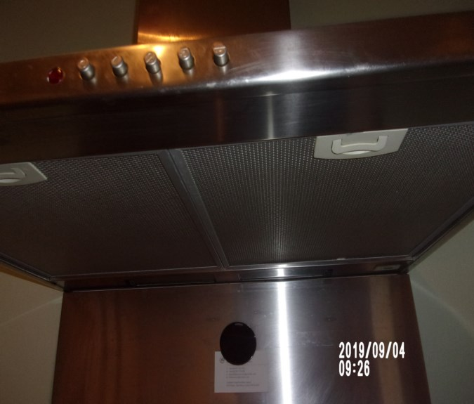 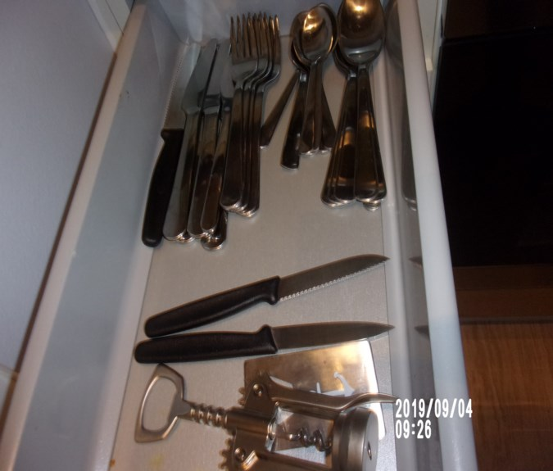

Oven Items in unit

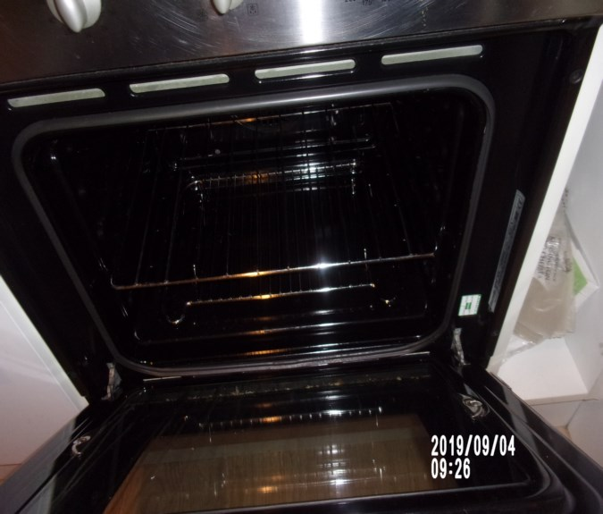 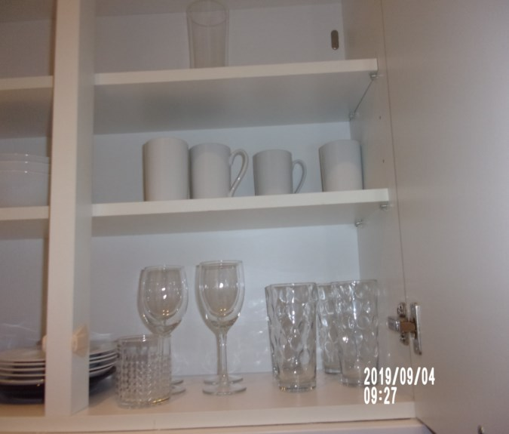

Items in unit Smoke alarm

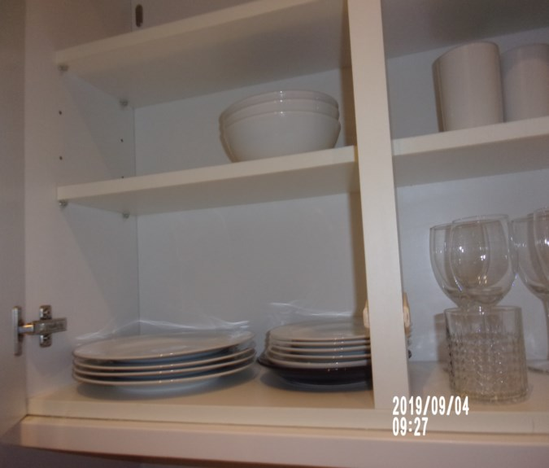 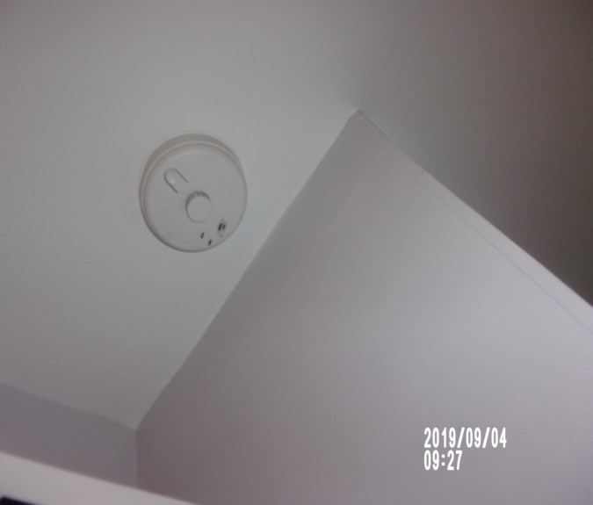

Manuals Splash back

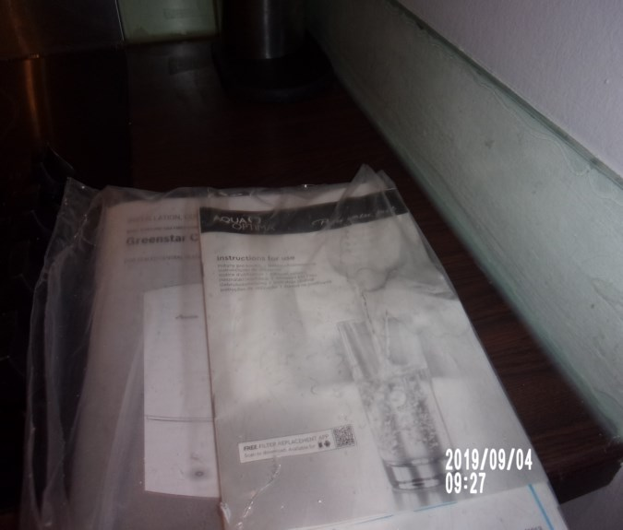 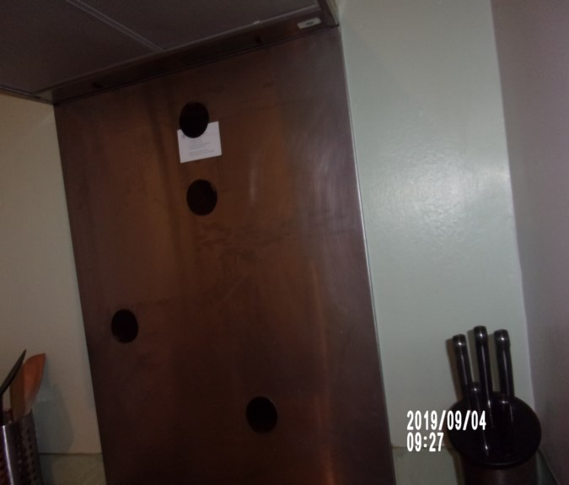

Hob

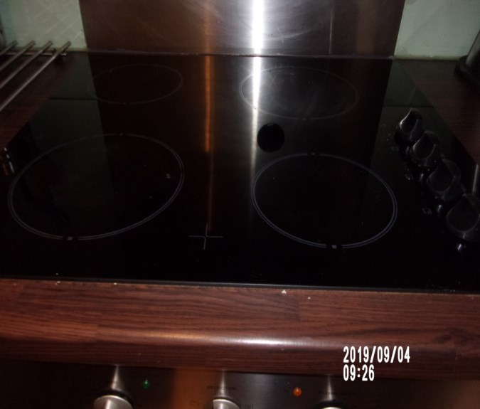

# BEDROOM 1

|  |  |  |  |  |  |
| --- | --- | --- | --- | --- | --- |
| **Door** | White painted frame, white painted flush door  Chrome lever handle | 1. Old defects under to frame  2. Upper level chip to frame  3. Scuffs usage to door  Exterior door some light shading seen to the top edges  1 or 2 x chips seen to the top and bottom edges at an angle |  |  |  |
| **Interior** | White painted frame, white painted flush door  Chrome lever handle  2x Stick on hooks | 1. Slightly paint marked to handle  2. Small low level chip to frame right hand side |  |  |  |
| **Ceiling** | Painted white with white painted coving | Slightly patchy appearance |  |  | Lighting |
| **Lighting** | 4 x Recessed halogen spot lights with chrome collar rims | ~~1~~ 2 x not working |  | T |  |

# BEDROOM 1

|  |  |  |  |  |
| --- | --- | --- | --- | --- |
| **Woodwork** | Painted white | 1. Old defects under  2. Scattered scuffs  ~~Dusty~~ |  |  |
| **Walls** | Part painted pale lilac  Part painted olive green | 1. Olive green section wall chip to top and bottom edges 2. 2 x screws and 1 x nail seen |  |
|  | Back wall:  1 x Single blank point  1 x Black single light switch | 1. Blank point is paint marked  Odd scuff to low level |  |
|  | Left hand side wall:  1 x Chrome single light switch  1 x Test socket | 1 x scuff at low level  High level staining left of window area  Minor rub marks seen at low level |  |
|  | Facing wall:  Painted olive green  2 x chrome double sockets  1 x chrome single aerial point | Painted over defects  Odd chips to paint |  |
|  | Right hand side wall | Intact  Odd scuff to low level |  |

# BEDROOM 1

|  |  |  |  |
| --- | --- | --- | --- |
| **Flooring** | Light wood veneer flooring  1 x Floor mounted chrome and black rubber tipped door stop | 1. Not inspected under furniture  2. Good condition  3. Tiny chip and scuffs forward of wardrobe |  |
| **Window** | White painted frame and casement, plain glazing as fitted  2 x Chrome finger pulls  1 x Chrome centre twist lock  White painted sill | 1. Old defects under to the frames  Sashes complete  Slightly soiled to exterior  Appears to be clean to interior  All attachments appear to be intact  Cracking to frame low level  Not able to use twist lock  Sill red marks |  |

# BEDROOM 1

|  |  |  |  |
| --- | --- | --- | --- |
| **Blind** | 1 x Cream roller blind  1 x Cream black out roller blind  2 x Plastic pulley cords | 1. Dust marked and in use to both  2. Creased to edges |  |
| **Radiator** | Enclosed behind a box casing with mesh panel to the front | 1. Not closely inspected  Appears to be intact |  |
| **Wardrobe** | Fitted white flush doors with chrome pull handles | Left hand side wardrobe exterior handle appears to be slightly loose |  |
| **Wardrobe 1 – left hand side** | Full length single cupboard  Interior:  Cream painted interior  Magnetic catches  1 x Cream shelf to high level  1 x Cream base shelf  1 x Chrome hanging rail | Light signs of usage seen to interior  Odd scuff to exterior |  |

# BEDROOM 1

|  |  |  |  |
| --- | --- | --- | --- |
| **Wardrobe 2 – centre** | Single cupboard with magnetic catches to the door  Interior:  2 x Chrome hanging rails  1 x Strip light fitting  1 x Cream shelf to high level  1 x Cream painted base shelf | 1. Light in working order  2. White paint marks to the underside of the upper shelf and to the back wall  3. Base shelf has some scuffs and marks  4. Scuffs and marks to mid to low level on the walls |  |
| **Wardrobe 3 – right hand side** | Full length single cupboard  Interior:  Cream painted interior  Magnetic catches  3 x Cream shelves  3 x Drawer unit to low level with white fronted drawer unit with chrome pull handles | 1. Scuffs to the drawer fronts and scuffs to the shelves  2. White paint marks to the interior of the door  3. Pull loose  Ring marks to shelf  Minor chips to upper level drawer top edge  Yellow stain to exterior base right hand side |  |
| **Bed** | Black and white stripped bed base | 1. Tear to the bed base on the right hand side near the headboard  Underside not inspected  Stain to side of mattress |  |

# BEDROOM 1

|  |  |  |  |
| --- | --- | --- | --- |
| **Mattress** | Cream upholstered mattress | Mattress not new |  |
| **Linen** | Grey quilted bed cover  Grey quilted throw  2 x pale grey over sized scatter cushions  2 x grey velvet over sized scatter cushions  1 x grey linen valance ~~seen on bed~~ | ~~Stained~~  ~~Further clean required~~  Now in reception |  |
| **Bedside tables** | Now 2 x medium wood with 2 x opaque glass shelves | Chip to wood  ~~Further clean required to shelf~~ |  |
| **Bedside lamp** | 1 x stainless steel and chrome shaded bedside lamp | Tested and working |  |
| **Tumblers** | 2 x glass tumblers | Now in kitchen |  |
| **Additional** | Wicker laundry basket |  |  |

Bedroom 1 Bedroom 1

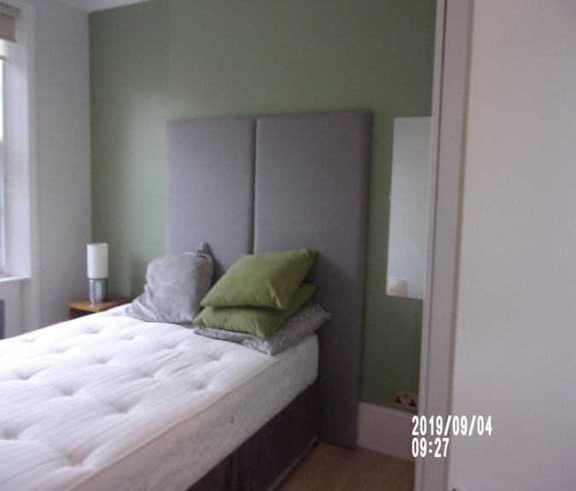 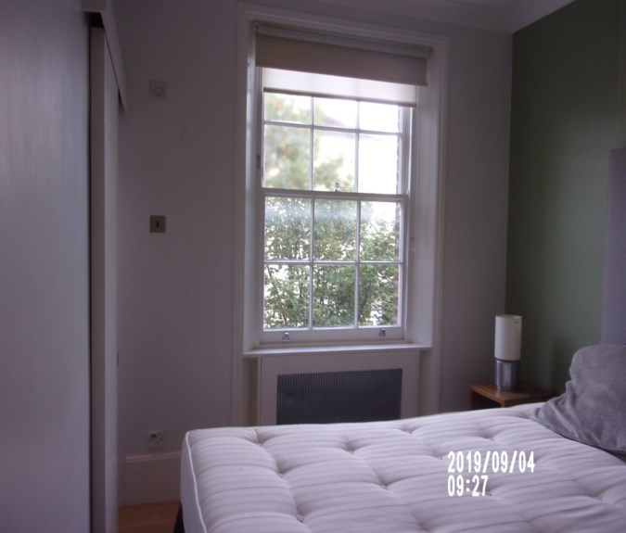

FFR label Bedroom 1

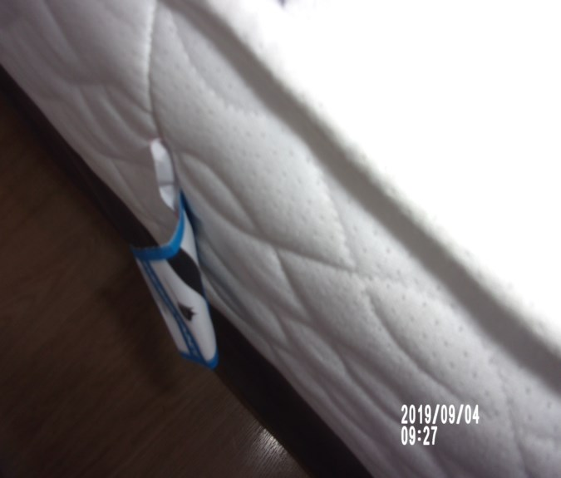 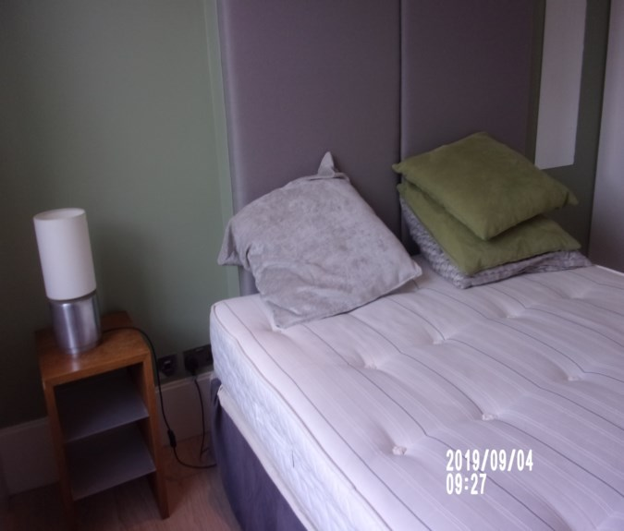

Stain mattress Stain window sill

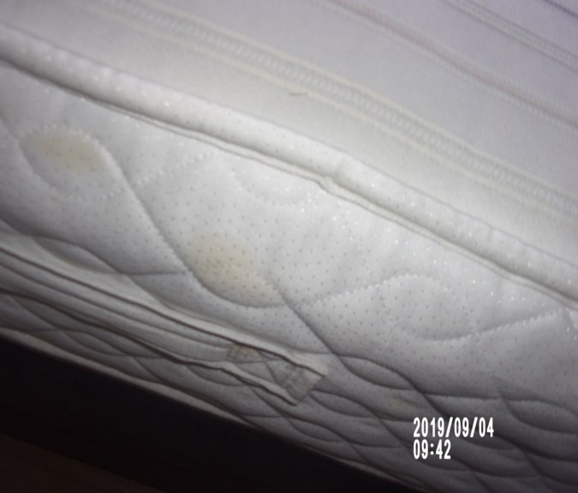 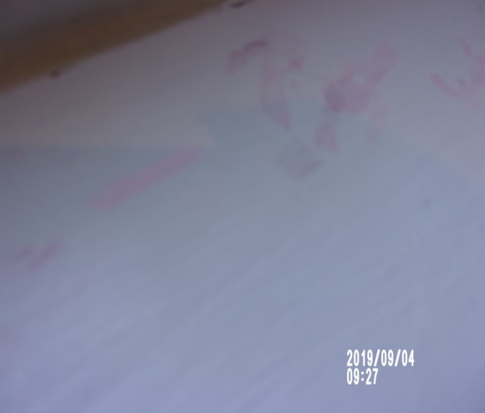

Wardrobe door yellow stain Wardrobe

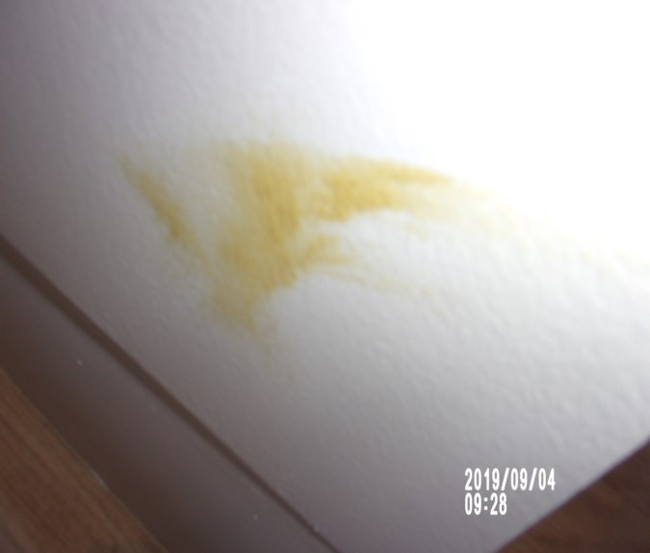 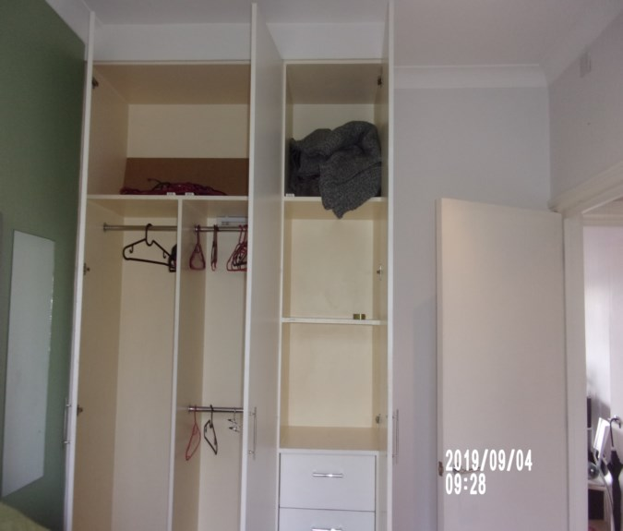

# ENSUITE

|  |  |  |  |  |
| --- | --- | --- | --- | --- |
| **Door** | White painted flush sliding door  Chrome inset pull handle  Silver coloured metal threshold runner | 1. Runner is in use and scratched  2. Few light scuffs  Veneer lifting low level  Line of yellow water spots upper level |  |  |
| **Interior** | White painted flush sliding door  Chrome inset pull handle with twist lock | 1. Low level scrapes mid level scuffs |  |  |
| **Ceiling** | Painted white  1 x Ceiling mounted Vortise extractor fan | ~~Appears to be in good order~~  Mould patches  1. Not tested |  | Lighting |
| **Lighting** | 3 x Recessed halogen spot lights with chrome collar rims | 1. ~~All tested and working order~~ 1 x not working |  |  |
| **Carbon monoxide alarm** | 1 x Carbon monoxide alarm seen | Tested for power |  |  |

**ENSUITE**

|  |  |  |  |
| --- | --- | --- | --- |
| **Walls** | Part painted pale grey/ lilac  Part beige matt tiling with cement grouting | Old defects underneath  Tile sections discolouration to the grout  Stress crack upper level near window |  |
|  | Back wall: | Grout is discoloured |  |
|  | Left hand side wall:  1 x Chrome shavers only socket  1 x Chrome hook |  |  |
|  | Facing wall:  1 x Chrome single fuse point and access panel above the toilet | ~~Some~~ Heavy scuffing above shelf  Some light scuffing seen to paint |  |
| **Woodwork** | Painted white |  |  |

**ENSUITE**

|  |  |  |  |  |
| --- | --- | --- | --- | --- |
| **Flooring** | Beige marble effect matt tiling with cement grouting | | 1. Grouting is discoloured  2. Crack forward of entry  3. Further crack near basin  Sealant appears to cracking in places |  |
| **Window** | White painted frame and casement, plain glazing as fitted  2 x chrome finger pulls  1 x chrome centre twist lock  White painted sill | | Usage to sill  Cracking to the paintwork to windows in places  Clean to interior  Slightly soiled to exterior |  |
| **Blind** | Off-white painted wooden venetian blind with pull cords and white painted wooden acorns | 1. Working order  2. No cleat – not safety compliant  Blind ~~is dusty~~ appears sun shade  Acorn chipped    1 x acorn missing  Rusting to top left hand side and right hand side | |  |
| **Radiator** | 1 x Chrome towel rail radiator with adjacent fuse point | Intact | |  |

**ENSUITE**

|  |  |  |  |
| --- | --- | --- | --- |
| **WC** | White ceramic low level flush WC  White plastic seat and lid  Chrome push flush | Flush tested and working  Some light discolouration underneath the water line |  |
| **Basin** | White rectangular ceramic basin  Chrome flip plug  Chrome mixer tap  Glass splash back behind | 1. Paint marked to the sink  Tested and working  Scale to ~~top~~ tap and plug  Water staining to right hand side of splash back |  |
| **Vanity unit** | Mirrored doors and chrome pull handles | 1. Worn and filled to base around pipe  ~~Not clean~~ |  |
| **Walk in shower** | Chrome frame with glass shower door  Chrome pull handle  White moulded base tray  Chrome waste  Wall mounted chrome shower holder, chrome shower head and flex  Wall mounted shower controls  Wall mounted chrome drench shower with control  1 x Plastic hook to wall | All attachments appear to be free of any scaling  Cleaning scratches to control panel and some rust mark to mixer tap and riser  Scale showerheads  Front cover missing from single control  Tray is stained  Grout is discoloured |  |
| **Additional** | Shower tidy |  |  |

**ENSUITE**

|  |  |  |  |
| --- | --- | --- | --- |
| **Contents** | 1 x Chrome toilet roll holder | Intact |  |
|  | 1 x Rectangular mirror panel above the basin | Some silvering to the bottom |  |
| **Fitted cupboard** | 2 x White painted flush doors  Interior:  Boiler | Cannot open  Doors catching along access panel to the ceiling  Not closely inspected |  |
| **Ledge** | White painted ledge over the toilet cistern | Some red ingrained and water staining seen to the top surface, otherwise intact |  |

En-suite Water spots door frame

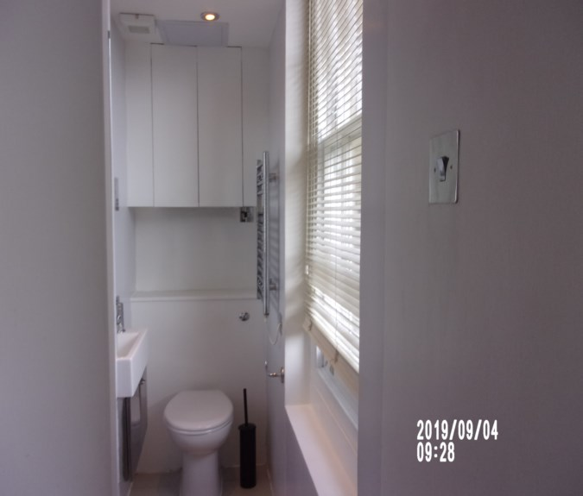 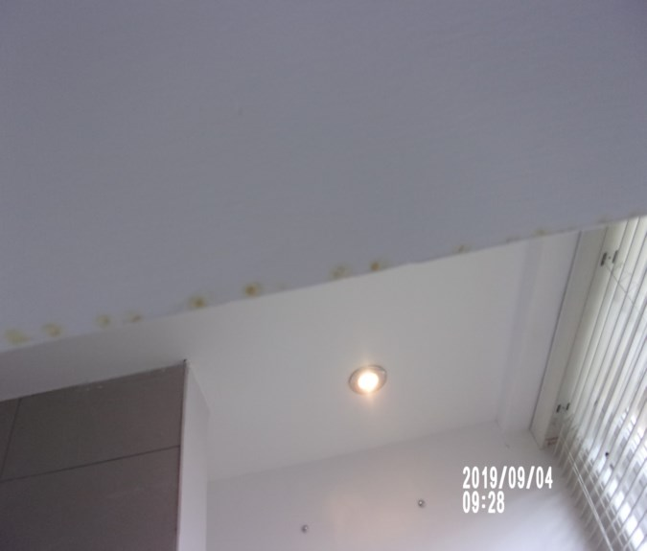

Carbon monoxide En-suite

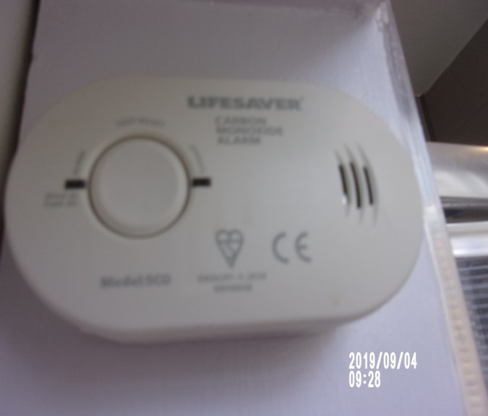 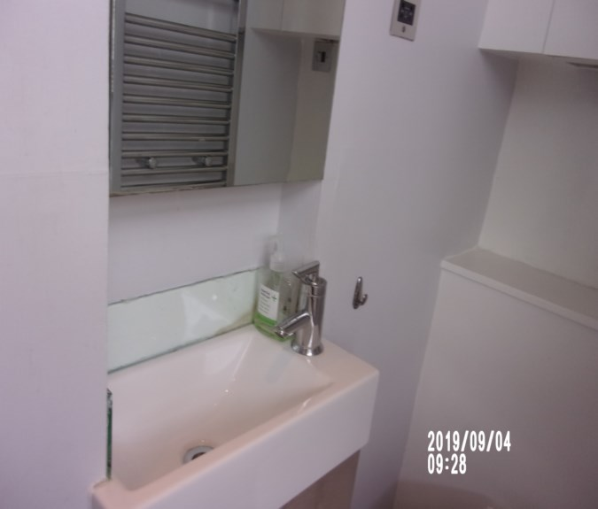

En-suite Scale showerhead

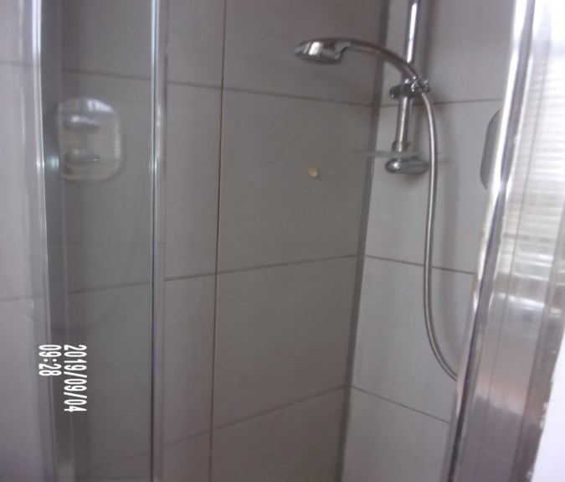 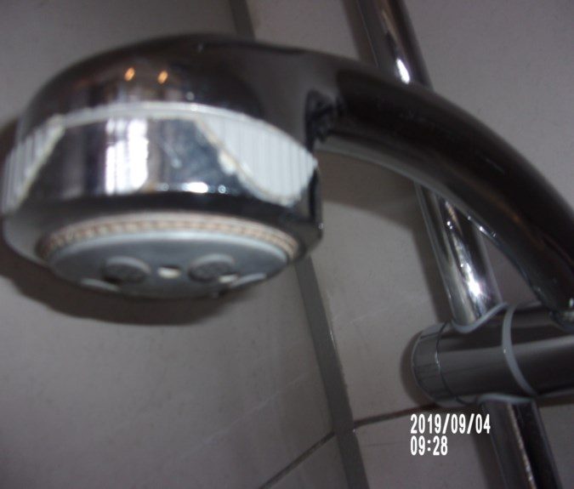

Cover missing bath control Shower tray stain

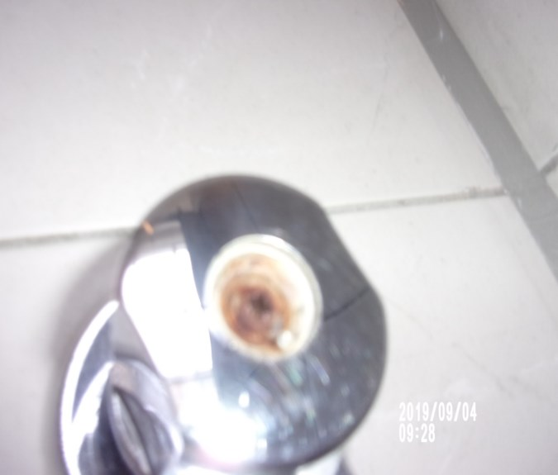 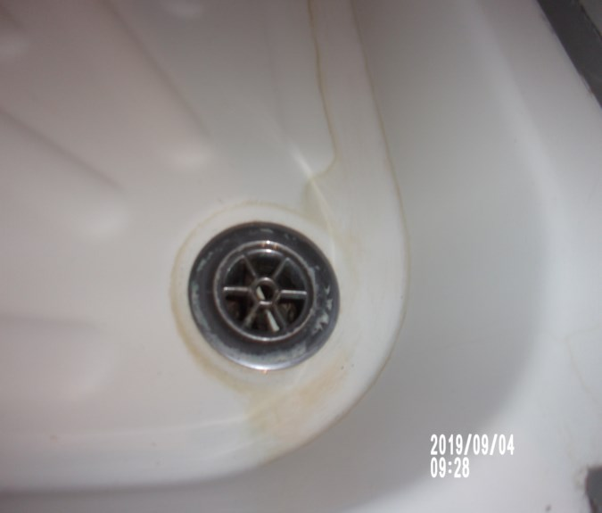

Splash back stain Under sink

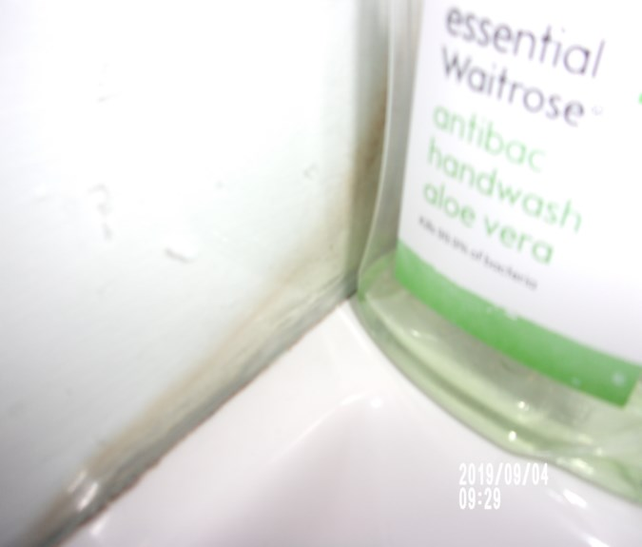 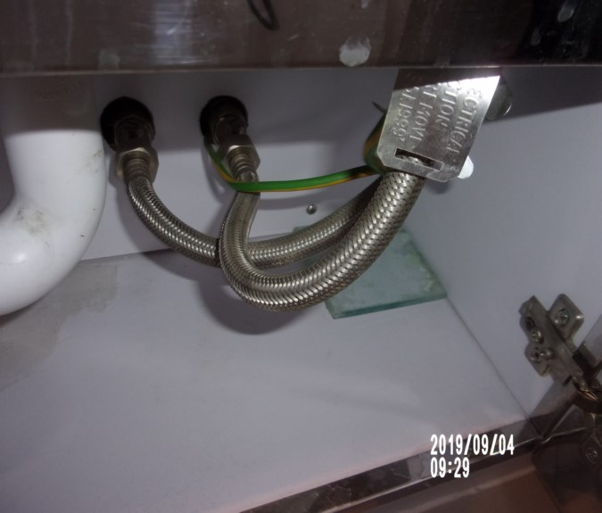

Water stain to blind Blind acorn missing

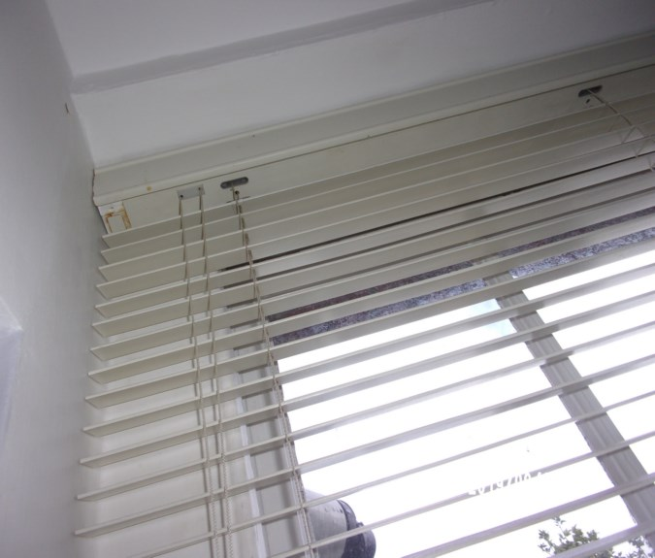 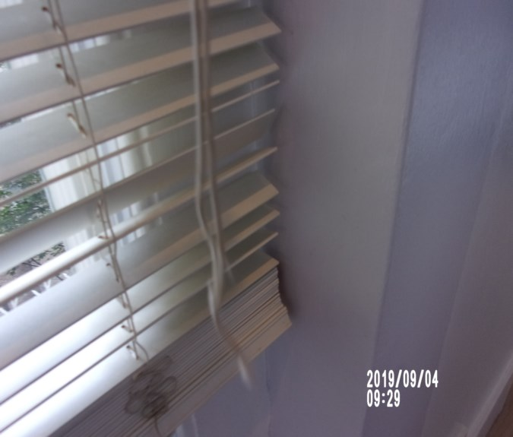

**RECEPTION**

|  |  |  |  |  |
| --- | --- | --- | --- | --- |
| **Door** | White painted frame, white painted flush door  Chrome lever handle | 1. Chipping to the base  2. Chip to door edge |  |  |
| **Interior** | White painted frame, white painted flush door  Chrome lever handle | 1. Slightly paint marked to handle  2. Small chip to leading edge  Interior door and frame intact |  |  |
| **Ceiling** | Painted white with white painted coving | Some light patchy paintwork in places  Intact |  | Lighting |
| **Lighting** | 6 x Recessed halogen spot lights with white collar rims | ~~4 x not~~ All working |  |  |
| **Woodwork** | Painted white | 1. Old defects under  2. Cable clipped to top in parts  Scuffs in places  Not fully inspected behind any furniture |  |

**RECEPTION**

|  |  |  |  |
| --- | --- | --- | --- |
| **Walls** | Part painted grey  Part painted red | Painted over defects  Light mid to low level marks |  |
|  | Back wall:  1 x Chrome single dimmer switch | Appears to be intact  Scuffs at mid and low level  2 x screws painted over high level |  |
|  | Left hand side wall:  Painted red | 1. Old defects under  Some light scuffing at mid and low level  1 x brass hook seen at high level |  |
|  | Facing wall:  1 x Chrome double socket |  |  |
|  | Right hand side wall  1 x Chrome double socket  1 x White single telephone point | 1 x brass hook seen at high level |  |

**RECEPTION**

|  |  |  |  |
| --- | --- | --- | --- |
| **Flooring** | Light wood flooring  1 x Floor mounted chrome and black rubber tipped door stop | 1. Few long scratches towards the window  2. Not inspected under furniture  3. Scratches/chips right hand side  Further use |  |
| **Window** | 2 x White painted frame and casement, plain single glazing as fitted  2 x Chrome finger pulls  1 x Chrome centre twist lock  White painted sill | Clean to interior  Lightly soiled to exterior  Cracking to frame |  |
| **Blind** | 1 x Off-white venetian blind with pull cord and white painted acorns  Perspex cleat seen right hand side of reveal | 1. Cord not compliant with safety regulations |  |
| **Radiator** | Enclosed behind a box casing with chrome mesh panel to the front |  |  |

**RECEPTION**

|  |  |  |  |
| --- | --- | --- | --- |
| **Shelves** | 4 x fixed shelves | Usage  Some light very minor signs of usage |  |
| **Sofa** | Black faux leather corner sofa in 3 pieces  1 x Double section  1 x Corner section  1 x Single section  4 x Black faux leather seat cushions  ~~1~~ 2 x Small grey ribbed scatter cushion  1 x grey / mauve scatter cushion  1 x Large grey faux suede scatter cushion  2 x pillows – no covers  1 x scattered cushion – no covers | 1. Odd scuffs and usage marks to the seat cushions  2. Pale mark to top of corner section  Light mark |  |
| **Coffee table** | Light wooden lm unit top surface black metal legs | 1. In good order |  |

**RECEPTION**

|  |  |  |  |
| --- | --- | --- | --- |
| **Side unit** | Black wood grain side unit  2 x frosted glass sliding doors to the front  Circular inset pull handles  Instruction manual - dryer | Ring mark to rear  Laminate appears to be coming loose to the front edges, most notably to the left  ~~Needs further clean~~ |  |
| **Dining table** | Frosted glass circular top with black painted wood grain pedestal base to the centre | Scratches  General light signs of usage  ~~Dusty~~  Ingrain water residue to centre |  |
| **Dining chairs** | ~~5~~ 4 x chrome framed dining chairs with white faux leather seats and backs  1 x chair located in bedroom | 1. 1 x has a large ring mark to the seat  2. Others have odd light scuffs and usage marks to the seats  3. Split to 1 x back and further usage  4. Additional split to chairs  5. In use |  |
| **Vacuum** |  | Appears damaged / taped over  Debris to interior  Now in bathroom |  |

**RECEPTION**

|  |  |  |  |
| --- | --- | --- | --- |
| **Contents** | 1 x brown wood grain unit with lower shelf and drawer with chrome handled  2 x white mugs in kitchen  Glass vase  2 x white bowls in kitchen  1 x vase with faux flowers  1 x stainless steel bowl  2 x stainless steel and black shaded lamps | 1. Lamp tested and working |  |
|  | 1 x picture frame  Large vase with faux roses and stones  3 x assorted flower vases  1 x purple / cream vase with lavender flower  Floor length mirror with white frame in plastic | Broken |  |

Reception Reception

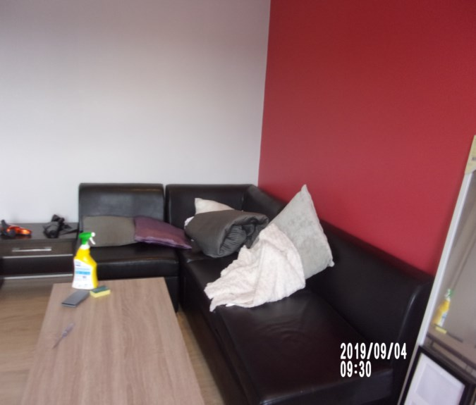 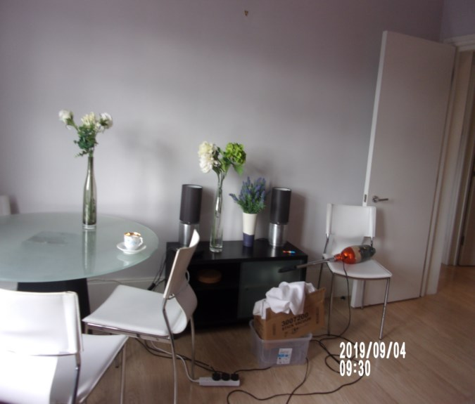

Reception Reception

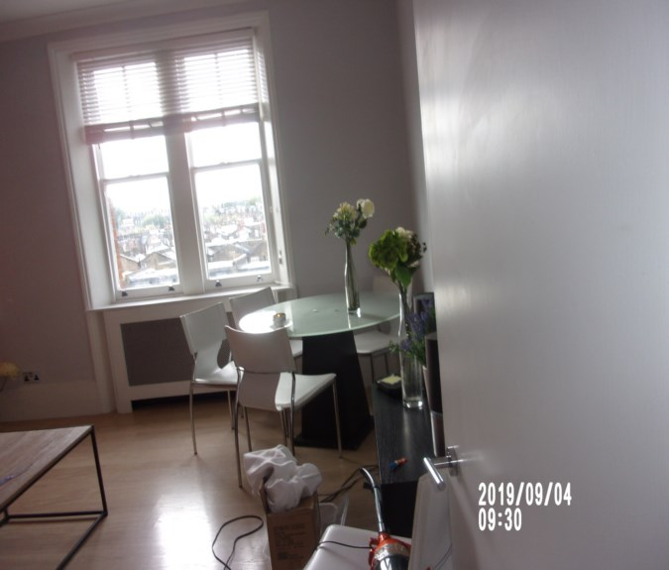 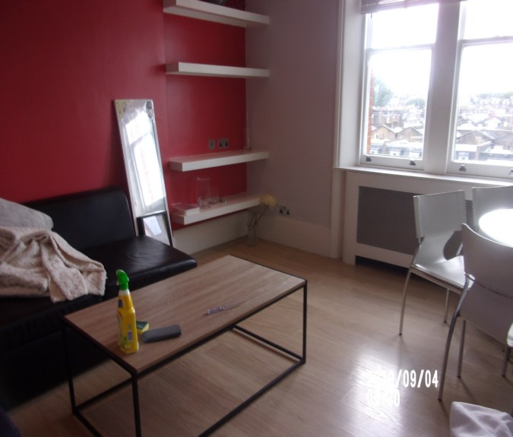

Stain dining table Items in unit

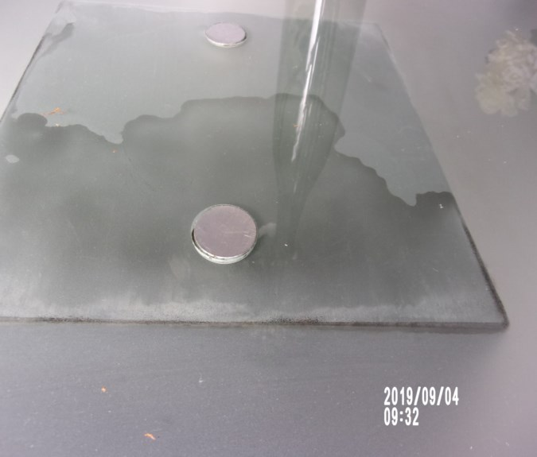 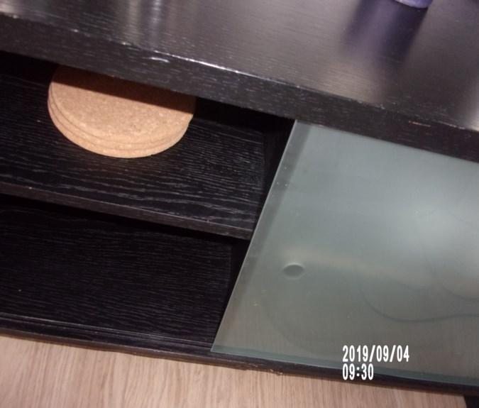

# BEDROOM 2

|  |  |  |  |  |
| --- | --- | --- | --- | --- |
| **Door** | White painted frame, white painted flush door  Chrome lever handle  Fire chain | 1. Old defects under to frame  2. Scuffs low level  Rubs to edge  Exterior frame both left and right hand side at low level light scuffing  1 x chip right hand side exterior frame  Exterior door some light scuffing at low level |  |  |
| **Interior** | White painted frame, white painted flush door  Chrome lever handle | 1. Paint marked to handle  2. Low level light usage  Interior door appears to be intact  Interior frame intact |  |  |
| **Ceiling** | Painted white with white painted coving | Appears to be intact |  | Lighting |
| **Lighting** | 4 x Recessed halogen spot lights with chrome collar rims | 1x spotlight appears to be coming loose from the surround – requires further maintenance  Working order |  |  |

# BEDROOM 2

|  |  |  |  |
| --- | --- | --- | --- |
| **Woodwork** | Painted white | 1. Old defects under  2. Light usage  Joint opening left hand side  Scattered scuff ~~and dusty to~~ top |  |
| **Walls** | Painted grey  Part painted light green | Painted over defects  Some scattered minor mid to low level scuffs |  |
|  | Back wall:  1 x Single blank point  1 x Chrome single light switch |  |  |
|  | Left hand side wall:  1 x Chrome aerial point  1 x Chrome double socket | 1. Aerial point is slightly loose  1” Paint chip  2 x screws seen at high level |  |
|  | Facing wall: | Patchy in left hand corner mid level  1 x brass hook seen at high level  1 or 2 x light scuff marks seen  Stress crack upper level right hand side of window |  |
|  | Right hand side wall  Painted light green  1 x Chrome single light switch  2 x Chrome double sockets | Some light drip marks seen at low level |  |

**BEDROOM 2**

|  |  |  |  |
| --- | --- | --- | --- |
| **Flooring** | Light wood veneer flooring  1 x Floor mounted chrome and black rubber tipped door stop | Appears to be intact  Light scratches to the top surface |  |
| **Window** | White painted frame and casement, plain glazing as fitted  2 x Chrome finger pulls  1 x Chrome centre twist lock  White painted sill | 1. Old defects under to the frames  Clean to interior and slightly soiled to exterior  Yellow spots to sill right hand side |  |
| **Blind** | White net curtain style roller blind  Chain break in place  Black roller blind and chain  1 x chain tidy seen  2 x Plastic pulley cords | Tested and working  Dusty  White residue to black roller blind |  |
| **Radiator** | Enclosed behind a box casing with chrome mesh panel to the front | 1. Not closely inspected |  |

**BEDROOM 2**

|  |  |  |  |
| --- | --- | --- | --- |
| **Wardrobe** | Fitted white flush doors with chrome pull handles | Angle chips to plinth |  |
| **Wardrobe 1 – left hand side** | Single cupboard  Interior:  Cream painted interior  Full length mirror panel  Magnetic catches  1 x Cream shelf to high level  1 x Cream base shelf  1 x Chrome hanging rail | 1. Odd usage marks  Further use to wardrobe interior  ~~Dusty shelves~~ |  |
| **Wardrobe 2 – centre** | Single cupboard  Interior:  2 x Chrome hanging rails  1 x Cream shelf to high level  1 x Cream painted base shelf | 1. Odd usage marks  2. Low level hinge detached  3. Cracking to rear panel  4. Light is working  ~~Heavy dust to shelves~~ |  |
| **Wardrobe 3 – right hand side** | Full length single cupboard  Interior:  Cream painted interior  Magnetic catches  3 x Cream fixed shelves  3 x Drawer unit to low level with white fronted drawer unit with chrome pull handles | 1. General usage marks to interior  2. Rubbing and chipping to front edges of the drawers  3. White paint marks to the back wall and interior door  Top 2 drawers chipped to edges – catching when opened  ~~Dusty to shelves~~ |  |

**BEDROOM 2**

|  |  |  |  |
| --- | --- | --- | --- |
| **Contents** | Pale grey upholstery bed base and headboard  4 x drawers  Mattress  Grey quilted bed cover and cream throw  2 x over sized grey patterned scatter cushions  2 x over sized pale grey scatter cushions | Mattress was not inspected at check in  Stain visible to mattress  Mattress FFR label seen  Throw now in reception  Items seen in wardrobe high shelf – cannot inspect |  |

Bedroom 2 Bedroom 2

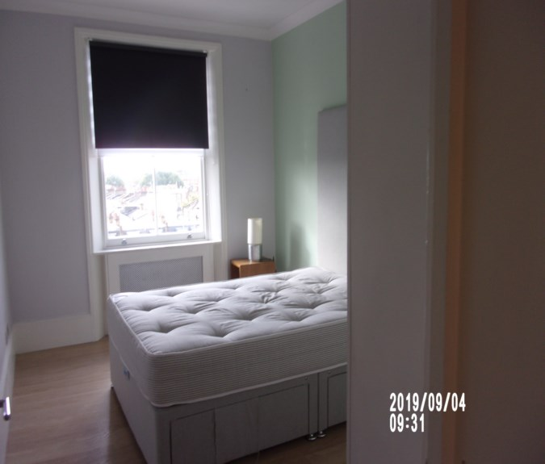 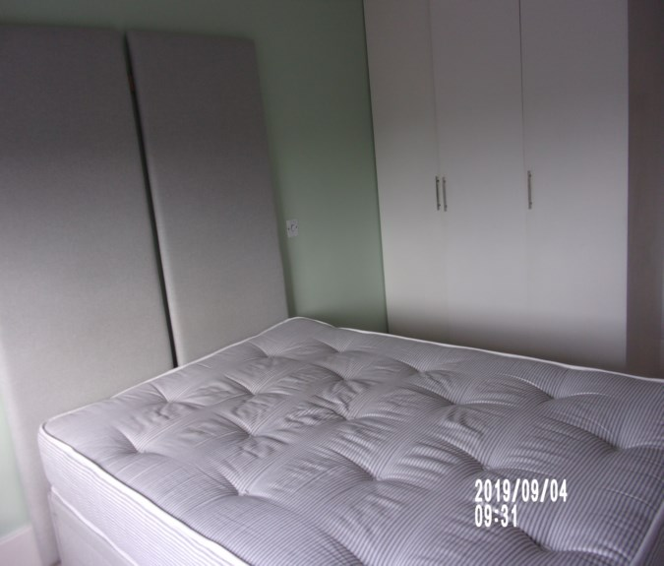

FFR label Mattress stain

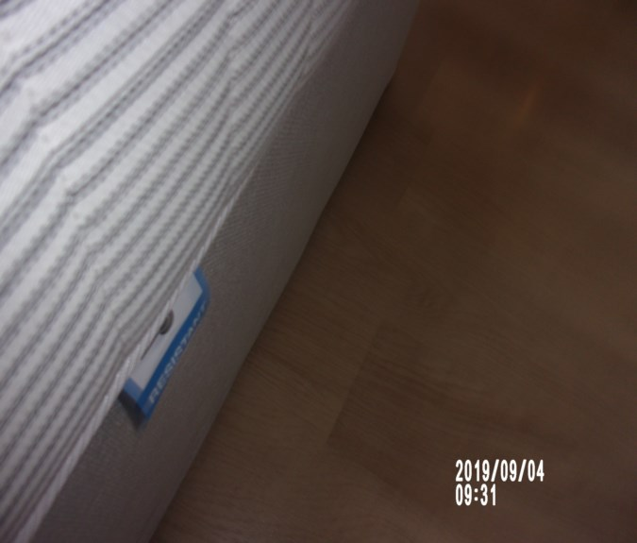 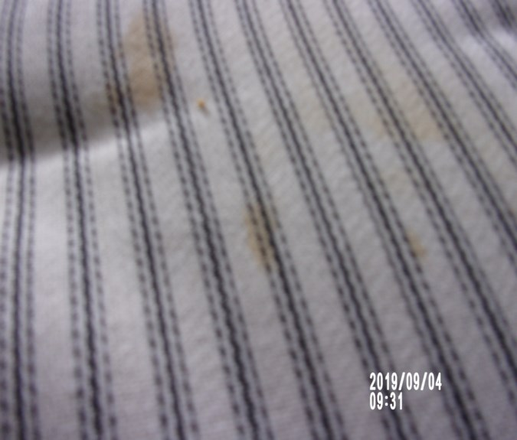

Wardrobe Dirt shelves

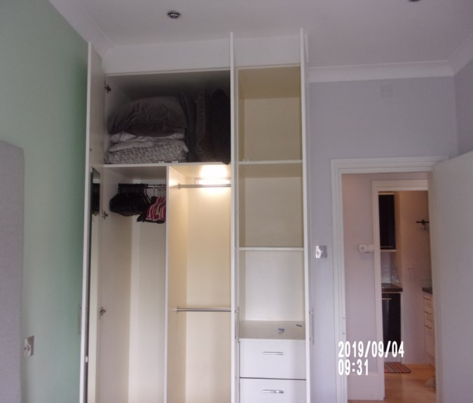 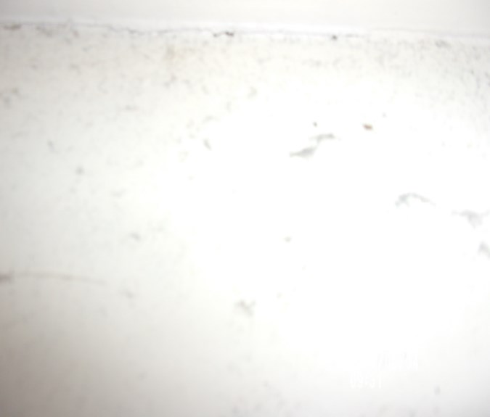

# DECLARATION AT CHECK IN

This inventory has been examined and, subject to marginal comments found to be correct.

## On behalf of the landlord

**on behalf of the tenant**

**commencement of tenancy**

## N.B

This inventory is correct to the best of our knowledge but advise you to examine its contents prior to signing, as we can not be held responsible for any errors or omissions. Descriptions are for identification purposes only.

The relevant utility companies must check all meter readings, as we can not be held responsible for any discrepancies

Please ensure that all items listedin this inventory are in the same location at the end of the tenancy.

ADDITIONAL AMENDMENTS

|  |  |  |
| --- | --- | --- |
| **DATE** | **DESCRIPTION OF CHANGES** | **AGENTS/LANDLORD SIGNATURE** |
|  |  |  |
|  |  |  |
|  |  |  |
|  |  |  |
|  |  |  |
|  |  |  |

WHEN ADDITIONS/AMENDMENTS ARE MADE BY THE LANDLORD, TENANT OR AGENT THE RELATIVE PARTIES MUST BE INFORMED

GENERAL COMMENT

It should be noted that it is not the responsibility of the Inventory Clerk to open, unpack, empty or itemise items stored in carrier bags or other containers unless it is made specifically clear they are the property of the Landlord.

|  |
| --- |
| **CHECK IN REPORT OF CONDITION AT: DATE:**04/09/ 2019 |

|  |  |
| --- | --- |
| **PROPERTY ADDRESS:** | 46 Warwick Chambers  Pater Street  London  W8 6EW |
| **CLIENT:** | London Central Portfolio |
| **CONTACT:** | Annabell Hughes |

|  |  |  |
| --- | --- | --- |
| **ELECTRIC** | **GAS** | **WATER** |
| **METER NUMBER:**  18L2111665 | **METER NUMBER:**  E061122 61 | **METER NUMBER:**  Unknown |
| **READING:**  Credit mode balance:1743  Rate 01 input: 625kwh | **READING:**  00237 .333 | **READING:**  Unknown |
| **LOCATION:**  Front exterior above door cupboard high level | **LOCATION:**  Bathroom cupboard | **LOCATION:**  Unknown |

|  |  |  |  |  |  |  |
| --- | --- | --- | --- | --- | --- | --- |
| **PROPERTY DESCRIPTION** | | | | | | |
| **ROOM** | **QTY** | **ROOM** | | **QTY** | **EXTERIOR AREAS** | **QTY** |
| RECEPTION | 1 | BATHROOMS | | 2 | FRONT GARDEN | 0 |
| OFFICE | 0 | WC | | 0 | REAR GARDEN | 0 |
| BEDROOMS | 2 | UTILITY | | 0 | SWIMMING POOL | 0 |
| DRESSING ROOM | 0 | STORE ROOM | | 0 | GARAGE | 0 |
| STAIRCASE & LANDINGS | 0 | CELLAR | | 0 | ANNEX | 0 |
|  |  |  | |  |  |  |
| □ HOUSE □ FLAT | | | □ UNFURNISHED □ FURNISHED | | | |

|  |
| --- |
| **GENERAL SUMMARY** |

|  |  |  |
| --- | --- | --- |
| **GENERAL CONDITION** | □ Professionally cleaned for start of tenancy :-  □ Domestically cleaned for the start of tenancy :-  □ Further general cleaning required:-  □A full professional clean is required :- | **FURTHER COMMENTS** |
| **ODOUR** | □ Pet □ Smoking □ Cooking  □Musty | □N/a |
| **DECORATIVE ORDER / WOODWORK** | □Advised freshly painted  □Good Order  □ Defects as noted  □ Dusty  □Woodwork scuffed/chipped |  |
| **FLOORING** | □Professionally cleaned for start of tenancy  □Good Order□ Defects as noted  □ Vacuumed for start of tenancy  □Requires further cleaning □ New |  |
| **CURTAINS / BLINDS** | □ Professionally cleaned for start of tenancy  □ Vacuumed insitu for start of tenancy  □Requires further cleaning  □Defects as noted□Good Order | □N/A |
| **BLIND REGULATIONS** | □Chain break connector in place  □Chain Tidyin place  □Regulations not met | □N/A |
| **UPHOLSTERY** | □ Professionally cleaned for start of tenancy  □ Vacuumed insitu for start of tenancy  □Good Order  □ New □ Defects as noted | □ N/A |
| **FFR LABELS** | Sofa □ FFR Label Seen □ Label Not seen Armchair □ FFR Label Seen □ Label Not seen Pouffee □ FFR Label Seen □ Label Not seen  **Mattress:**  Bed 1 □ FFR Label Seen □ Label Not seen Bed 2 □ FFR Label Seen □ Label Not seen Bed 3 □ FFR Label Seen □ Label Not seen Bed 4 □ FFR Label Seen □ Label Not seen  **□ Client informed Name……………………….……** |  |
| **LINEN** | □ New □ In use □ None provided  □Domestically cleaned □ Freshly laundered | □ Requires further cleaning |
| **LIGHTS** | □ All working order  □ Bulbs missing / not working |  |
| **KITCHEN / APPLIANCES** | □ All clean order  □ All Appliances power tested  □Fridge left open power off □Freezer left open power off  □Fridgeleft shut power on □Freezer left shut power on | □ Requires further cleaning |
| **BATHROOMS/**  **WC** | □ Clean □ All fitments free of lime scale  □Water outlets tested and working | □ Mildew to areas as noted  □ Requires further cleaning |
| **WINDOWS** | □ Fitments complete  □ Clean to interior □Clean to exterior | □ Requires further cleaning |
| **GARDEN /**  **TERRACE/**  **BALCONY** | □ Seasonal order | □ N/A  □Further attention required |

|  |
| --- |
| **POSITION OF** |

|  |  |
| --- | --- |
| **STOP COCK** | Kitchen cupboard |
| **FUSE BOARD** | Hallway |
| **ALARM PANEL** | None |

|  |
| --- |
| **MANUALS PROVIDED** |
| **□** Washing machine □ Alarm □ TV □ Tumble Dryer □ Boiler □ Extractor hood  □ Dishwasher □ Microwave oven □ Oven  □ Fridge freezer □ Phone □ Waste disposal  □None provided |

|  |
| --- |
| **FIRE SAFETY** |

|  |  |
| --- | --- |
| **SMOKE ALARM 1** | □ Mains powered □ Power light on □ Too high to read □ Not visible  □**T**ested with Canned smoke and working order  □**Location: -** ……………………………………………………..  □**Expiry date** ………/…………/……..  **□ SMOKE ALARM NOT WORKING – Agentadvised**  Person advised: - Name ……………………………… |
| **SMOKE ALARM 2** | □ Mains powered □ Power light on □ Too high to read □ Not visible  □Tested with Canned smoke and working order    □**Location: -** ………………………………………………………….  □**Expiry date** ………/…………/……..  **□ SMOKE ALARM NOT WORKING – Agentadvised**  Person advised: - Name ……………………………… |
| **SMOKE ALARM 3** | □ Mains powered □ Power light on □ Too high to read □ Not visible  □Tested with Canned smoke and working order  □**Location**: - ………………………………………………………………  □**Expiry date** ………/…………/……..  **□ SMOKE ALARM NOT WORKING – Agentadvised**  Person advised: - Name ……………………………… |
| **CARBON MONOXIDE ALARM** | □ Tested and working order □Light seen □N/a |

|  |  |  |  |
| --- | --- | --- | --- |
| **KEYS** | | | |
| **KEY TYPE** | **SERIAL NUMBER** | | **QTY** |
|  |  | |  |
|  |  | |  |
|  |  | |  |
|  |  | |  |
|  |  | |  |
| **KEYS RECEIVED BY:** □AGENT □TENANT □LANDLORD □CONCIERGE □BUILDER  □ Management keys used □ None provided  *Tick as applicable | | | |
| **NAME PRINTED:**  RORY  **……………………………………………………..** | | **SIGNATURE :**  **…………………………………………………….** | |

*N.B – Heavy items will not be moved or inspected behind/under, for health & safety reasons. We will not be held liable should any damages/stains/marks be found during the tenancy in these areas. Should the occupant find any of the above they should, inform the landlord/agent immediately and if/where possible take photographic evidence and pass to the relevant parties.

|  |  |  |
| --- | --- | --- |
| **CLIENT CALLED AT** | | |
| **TIME:** | **VOICE MESSAGE LEFT FOR:** | **SPOKEN WITH:** |

|  |  |  |
| --- | --- | --- |
| **IN ATTENDANCE AT CHECK IN** | | |
|  **INDEPENDENT CLERK**  ** TENANT**  ** LANDLORD**  ** AGENT** | **NAME PRINTED**    ……………………………………………… | **SIGNATURE**  ……………………………………..………….. |

|  |
| --- |
| **In attendance:** □LANDLORD □TENANT □INVENTORY CO. □RELOCATION REP |

|  |  |
| --- | --- |
| **NAME PRINTED**  ………………………………..……………… | **SIGNATURE**  ………………………………..……………….. |

|  |
| --- |
| **CHECK OUT REPORT OF CONDITION AT: DATE:07**/09/2020 |

|  |  |
| --- | --- |
| **PROPERTY ADDRESS:** | 46 Warwick Chambers  Pater St  Kensington  W8 6EW |
| **CLIENT:** | London Central Portfolio |
| **CONTACT:** | Georgia Cole |

|  |  |  |
| --- | --- | --- |
| **ELECTRIC** | **GAS** | **WATER** |
| **METER NUMBER:**  18L2111665 | **METER NUMBER:**  E06112261 | **METER NUMBER:**  Unknown |
| **READING:**  Credit mode balance: 2362 | **READING:**  01212.600 | **READING:**  Unknown |
| **LOCATION:**  Front exterior above door cupboard high level | **LOCATION:**  Bathroom cupboard | **LOCATION:**  Unknown |
| **SUPPLIER:**  EDF | **SUPPLIER:** | **SUPPLIER:** |

|  |  |  |  |  |  |  |
| --- | --- | --- | --- | --- | --- | --- |
| **PROPERTY DESCRIPTION** | | | | | | |
| **ROOM** | **QTY** | **ROOM** | | **QTY** | **EXTERIOR AREAS** | **QTY** |
| RECEPTION | 1 | BATHROOMS | | 2 | FRONT GARDEN | 0 |
| OFFICE | 0 | WC | | 0 | REAR GARDEN | 0 |
| BEDROOMS | 2 | UTILITY | | 0 | SWIMMING POOL | 0 |
| DRESSING ROOM | 0 | STORE ROOM | | 0 | GARAGE | 0 |
| STAIRCASE & LANDINGS | 0 | CELLAR | | 0 | ANNEX | 0 |
| STUDY | 0 | BALCONY | | 0 |  |  |
| KITCHEN | 1 |  | |  |  |  |
| □ HOUSE □ FLAT | | | □ UNFURNISHED □ FURNISHED | | | |

|  |
| --- |
| **GENERAL SUMMARY** |

|  |  |  |  |
| --- | --- | --- | --- |
| **GENERAL CONDITION** | □ Professionally cleaned for end of tenancy :-  □ Domestically cleaned for the end of tenancy :-  □ Further general cleaning required:-  □ A full professional clean is required :-  □ Cleaning company present :- | **FURTHER COMMENTS**  □ Tenants items left in property  □ Rubbish to be removed | |
| **ODOUR** | □ Pet □ Smoking □ Cooking | □ N/a | |
| **DECORATIVE ORDER/**  **WOODWORK** | □ Advised freshly painted  □ Defects as noted □ Dusty  □ Woodwork scuffed/chipped |  | |
| **FLOORING** | □ Professionally cleaned for end of tenancy  □ Vacuumed for end of tenancy |  | |
| **CURTAINS / BLINDS** | □ Professionally cleaned for end of tenancy  □ Vacuumed in situ for end of tenancy |  | |
| **UPHOLSTERY** | □ Professionally cleaned for end of tenancy  □ Vacuumed in situ for end of tenancy  □ Defects as noted | □ N/A |
| **LINEN** | □ In use □ None provided  □ Freshly laundered | □ Requires further cleaning |
| **LIGHTS** | □ All working order  □ Bulbs missing / not working |  |
| **KITCHEN / APPLIANCES** | □ All clean order  □ All appliances power tested  □ Fridge left open power off □ Freezer left open power off  □ Fridge left shut power on □ Freezer left shut power on | □ Requires further cleaning |
| **BATHROOMS/**  **WC** | □ Clean □ All fitments free of lime scale  □ Water outlets tested and working | □ Mildew to areas as noted  □ Requires further cleaning |
| **WINDOWS** | □ Fitments complete  □ Clean to interior / exterior | □ Requires further cleaning |
| **GARDEN /**  **TERRACE** | □ Seasonal order | □ N/A  □Further attention required |
| **TELEPHONE** | □ Handset Provided □ None provided |  |

|  |  |
| --- | --- |
| **CLEANING RECEIPT SUPPLIED** | □ None provided |

|  |  |
| --- | --- |
| **Company name**  **& Amount** |  |

|  |
| --- |
| **MISSING MANUALS** |
|  |

*N.B – Heavy items will not be moved or inspected behind/under, for health & safety reasons. We will not be held liable should any damages/stains/marks be found during the tenancy in these areas. Should the occupant find any of the above they should, inform the landlord/agent immediately and if/where possible take photographic evidence and pass to the relevant parties.

|  |  |
| --- | --- |
| **TENANTS FORWARDING DETAILS** | |
| **NAME:**  **ADDRESS:**  **TEL:**  **EMAIL:** |  |

|  |  |  |  |
| --- | --- | --- | --- |
| **KEYS** | | | |
| **KEY TYPE** | **SERIAL NUMBER** | | **QTY** |
| bramah | 85d 11110 | | 1 |
| yale |  | | 1 |
|  |  | |  |
|  |  | |  |
|  |  | |  |
| **KEYS RECEIVED BY:**  □ AGENT □ TENANT □ LANDLORD □ CONCIERGE □ BUILDER  □ Management keys used 1 x bramah( 85d 11110), 1 x brass yale □ None provided  *Tick as applicable | | | |
| **NAME PRINTED:**  ANNABEL HUGHES  **……………………………………………………..** | | **SIGNATURE :**  **…………………………………………………….** | |

|  |  |  |
| --- | --- | --- |
| **CLIENT CALLED AT** | | |
| **TIME:** | **VOICE MESSAGE LEFT FOR:** | **SPOKEN WITH:** |

|  |  |  |
| --- | --- | --- |
| **IN ATTENDANCE AT CHECK OUT** | | |
| **INDEPENDENT INVENTORY CLERK** | **NAME PRINTED**  ……………………………………………… | **SIGNATURE**  ……………………………………..………….. |

|  |
| --- |
| **In attendance:**  □ LANDLORD □ TENANT □ INVENTORY CO. □ RELOCATION REP |

|  |  |
| --- | --- |
| **NAME PRINTED**  ………………………………..……………… | **SIGNATURE**  ………………………………..……………….. |